**Week 1**

**Syllabus**

# Professional Certificate Career Support

## Coursera Community and Career Support

As a Data Science learner on Coursera, you have access to networking opportunities in Coursera’s [Professional Certificate Community](http://bit.ly/2Ij0Kg9) and [Data Science](http://bit.ly/2VEY9VI) forums. Talk about what you’re learning, ask questions, find peers to work with on projects, and share your career goals.

## Post-Completion Career Support Services for Professional Certificates

Completing a Professional Certificate on Coursera unlocks access to a private Professional Certificate Alumni Resources community, which provides exclusive career support resources, including:

* Step-by-step **guide to ensure your success** at every stage of your job search.
* 1 year of **free access** to Big Interview’s expert video lessons, resume builder, and interactive interview practice tools (a $79/month value).
* **A network** and support of fellow completers of Coursera Professional Certificates.
* A variety of **special offers** such as career coaching, webinars, and more.

After completing your Professional Certificate, you’ll get an email telling you how to access these career support resources.

Questions? You can also always contact Coursera Careers Team by emailing [career-support@coursera.org](mailto:professional-certificate-career-support@coursera.org).

**Defining Data Science**

Data science is the field of exploring, manipulating, and analyzing data, and using data to answer questions or make recommendations. Data science involves using data to answer questions or make recommendations.

* Data Science is a process, not an event. It is the process of using data to understand different things, to understand the world.
* For me is when you have a model or hypothesis of a problem, and you try to validate that hypothesis or model with your data.
* Data science is the art of uncovering the insights and trends that are hiding behind data. It's when you translate data into a story. So use storytelling to generate insight. And with these insights, you can make strategic choices for a company or an institution.
* Data science is a field about processes and systems to extract data from various forms of whether it is unstructured or structured form.
* Data science is the study of data. Like biological sciences is a study of biology, physical sciences, it's the study of physical reactions. Data is real, data has real properties, and we need to study them if we're going to work on them.
* Data Science involves data and some science. The definition or the name came up in the 80s and 90s when some professors were looking into the statistics curriculum, and they thought it would be better to call it data science. But what is Data Science? I'd see data science as one's attempt to work with data, to find answers to questions that they are exploring. In a nutshell, it's more about data than it is about science. If you have data, and you have curiosity, and you're working with data, and you're manipulating it, you're exploring it, the very exercise of going through analyzing data, trying to get some answers from it is data science. Data science is relevant today because we have tons of data available. We used to worry about lack of data. Now we have a data deluge. In the past, we didn't have algorithms, now we have algorithms. In the past, the software was expensive, now it's open source and free. In the past, we couldn't store large amounts of data, now for a fraction of the cost, we can have gazillions of datasets for a very low cost. So, the tools to work with data, the very availability of data, and the ability to store and analyze data, it's all cheap, it's all available, it's all ubiquitous, it's here. There's never been a better time to be a data scientist.

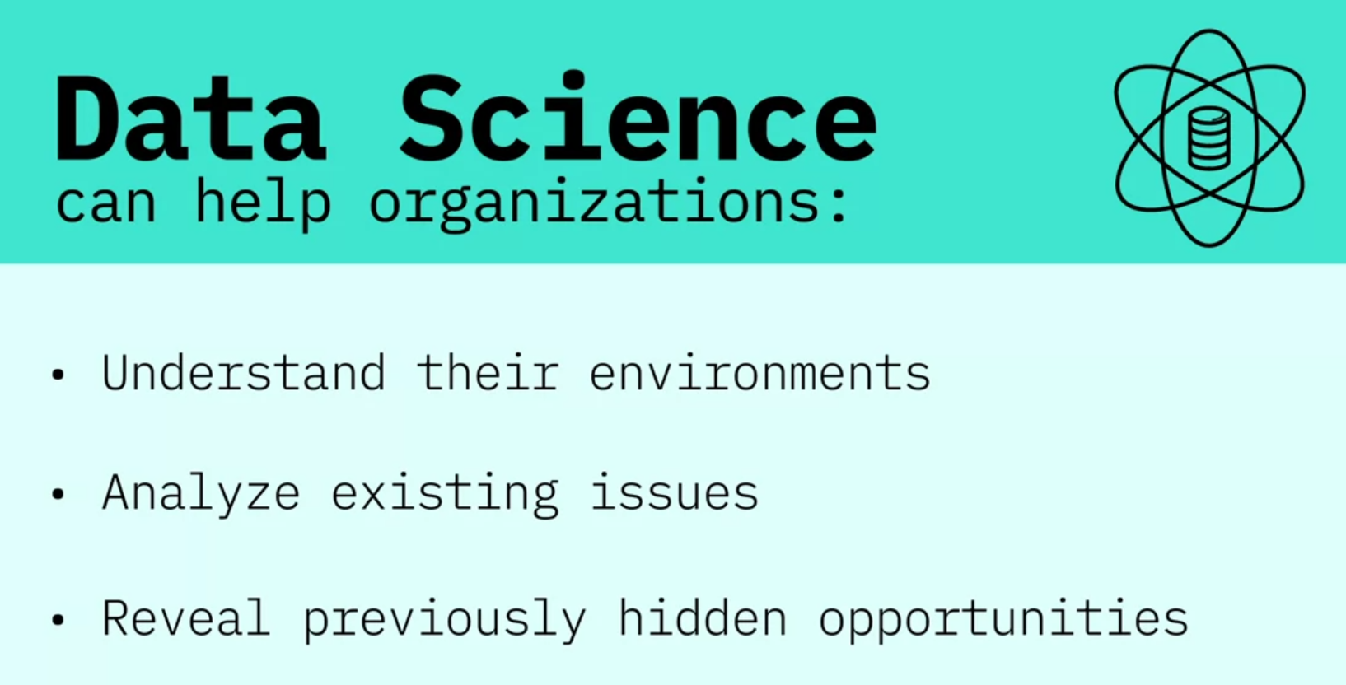

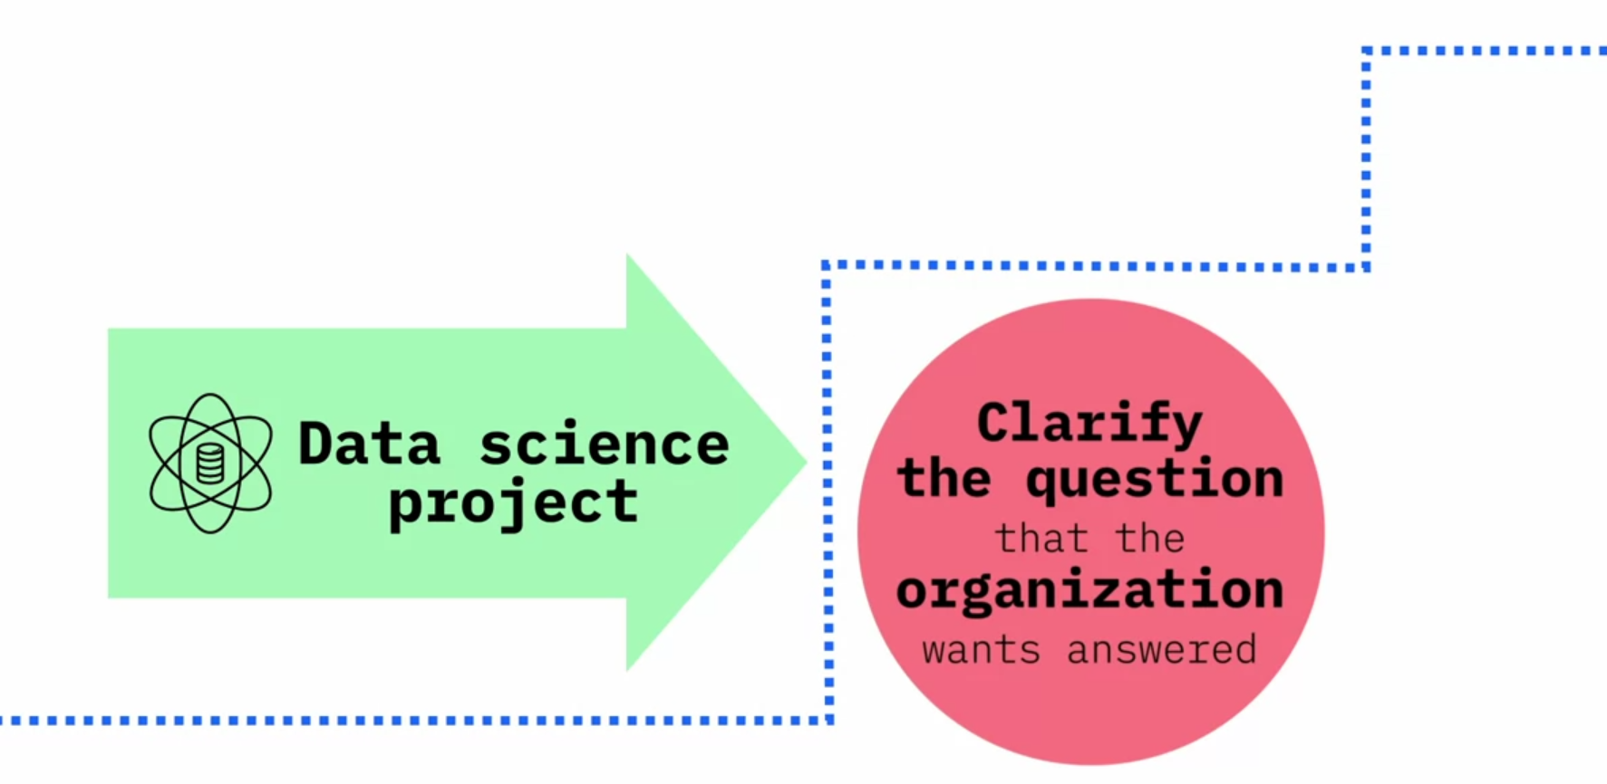

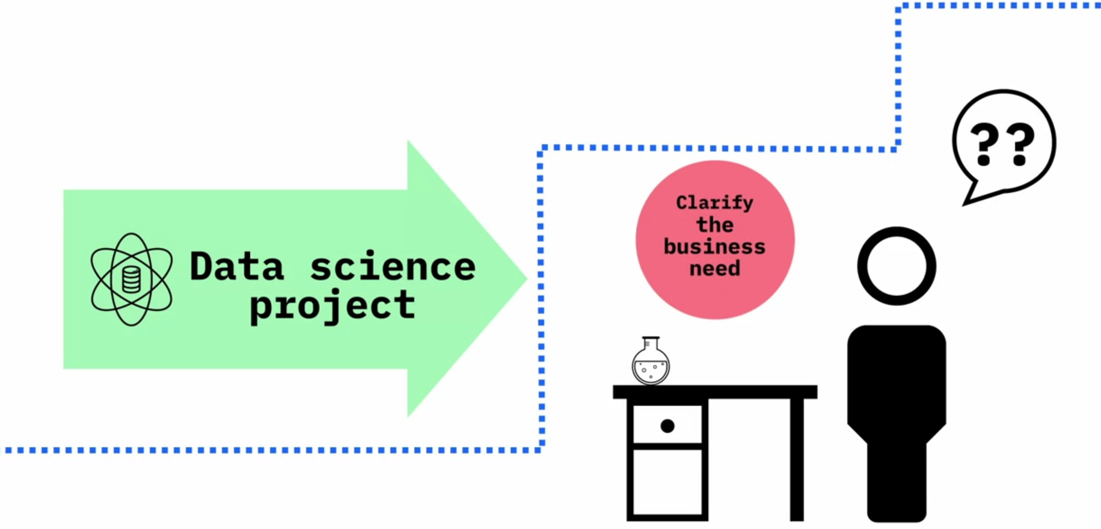

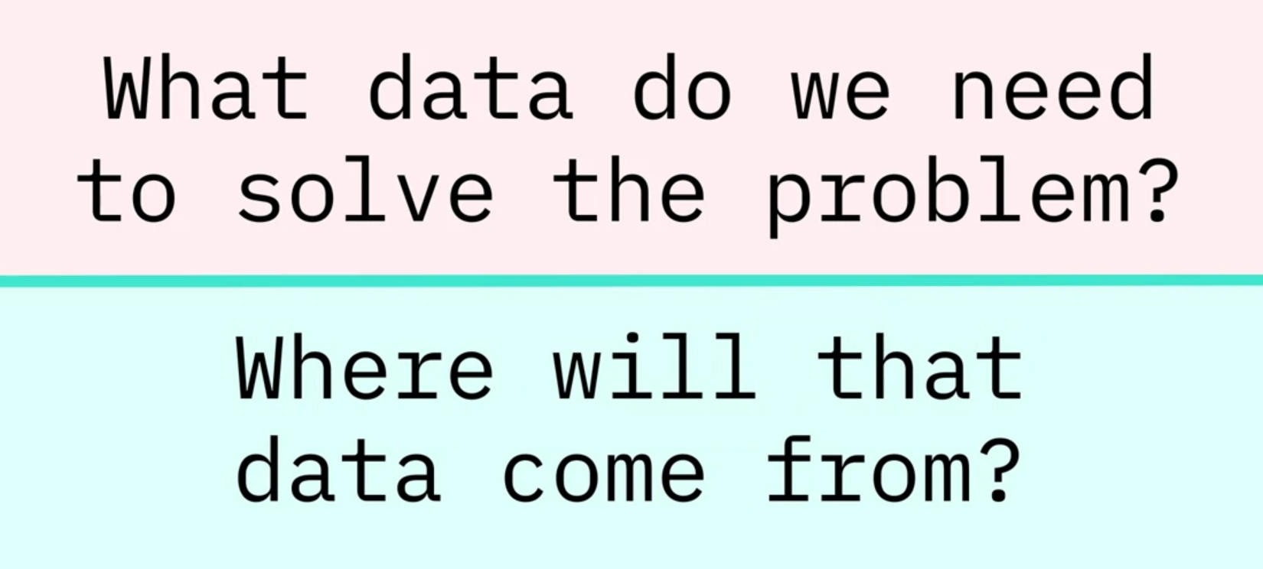

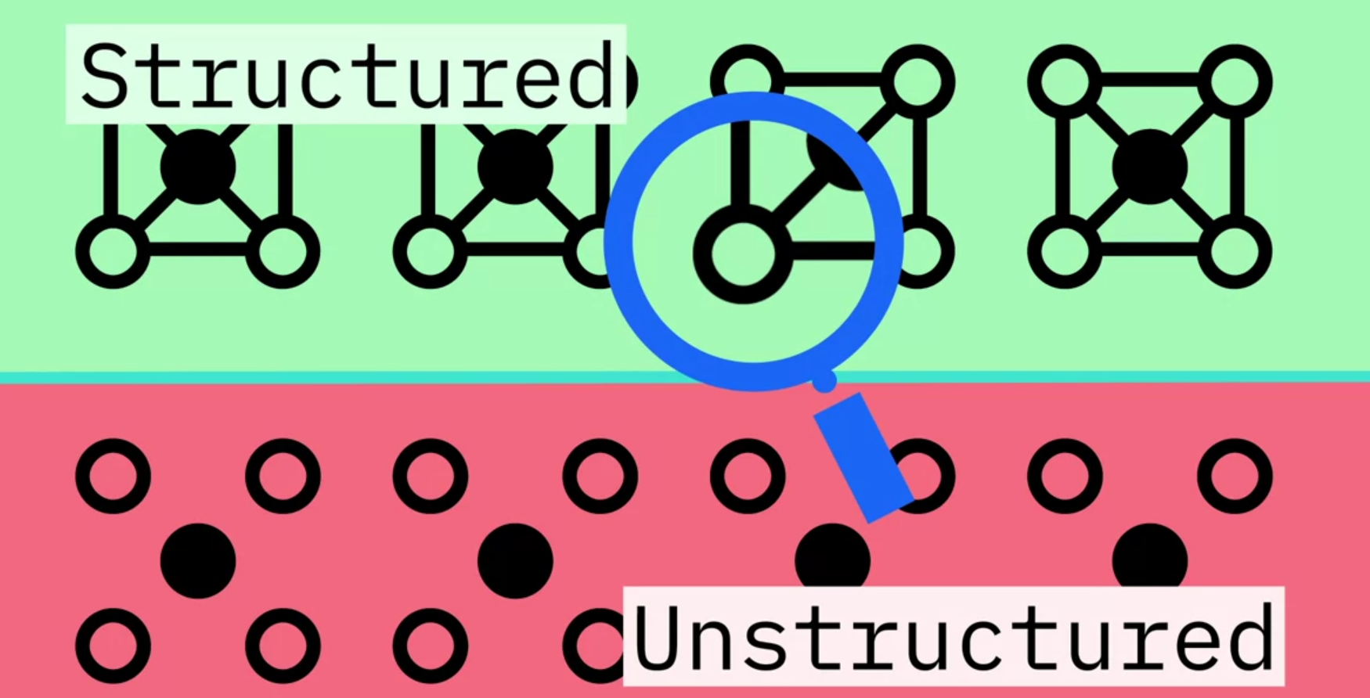

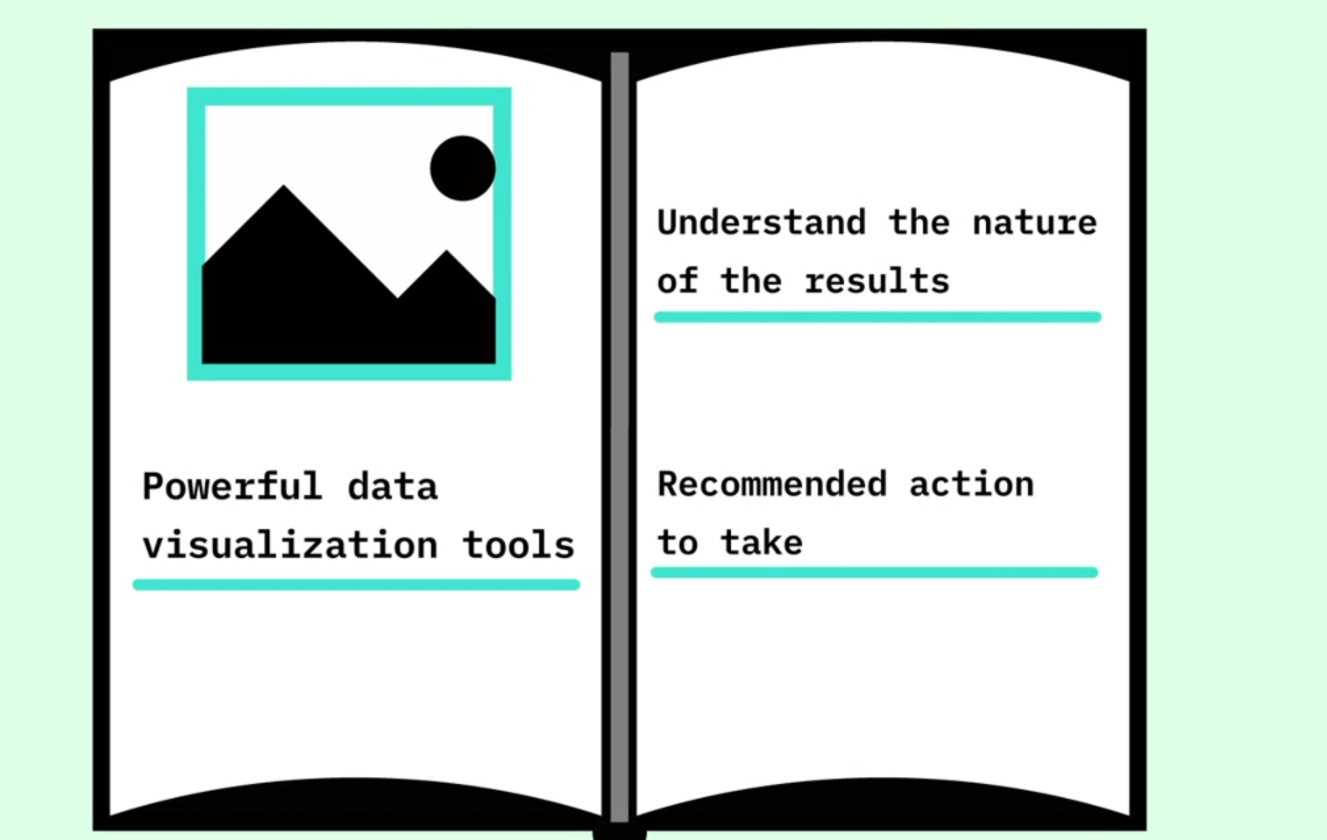

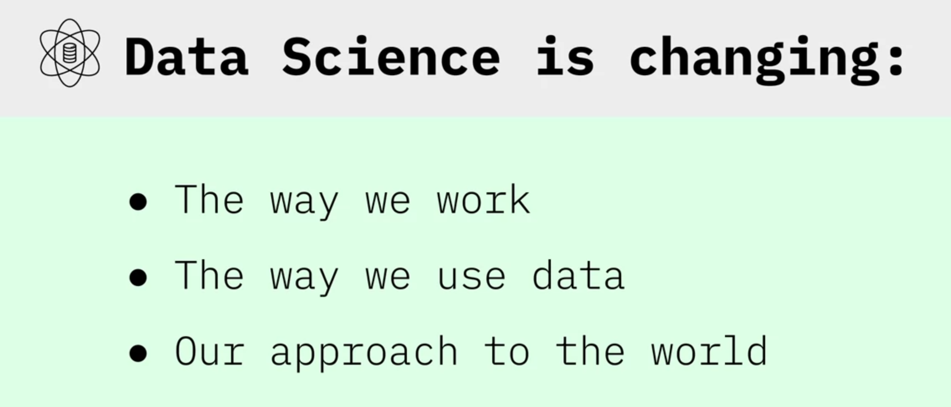

My advice to an aspiring data scientist is to be curious, extremely argumentative and judgmental. Curiosity is absolute must. If you're not curious, you would not know what to do with the data. Judgmental because if you do not have preconceived notions about things you wouldn't know where to begin with. Argumentative because if you can argument and if you can plead a case, at least you can start somewhere and then you learn from data and then you modify your assumptions and hypotheses and your data would help you learn. And you may start at the wrong point. You may say that I thought I believed this, but now with data I know this. So, this allows you a learning process. So, curiosity being able to take a position, strong position, and then moving forward with it. The other thing that the data scientist [should] would need is some comfort and flexibility with analytics platforms: some software, some computing platform, but that's secondary. The most important thing is curiosity and the ability to take positions. Once you have done that, once you've analyzed, then you've got some answers. And that's the last thing that a data scientist need, and that is the ability to tell a story. That once you have your analytics, once you have your tabulations, now you should be able to tell a great story from it. Because if you don't tell a great story from it, your findings will remain hidden, remain buried, nobody would know. Your rise to prominence is pretty much relying on your ability to tell great stories. A starting point would be to see what is your competitive advantage. Do you want to be a data scientist in any field or a specific field? Because, let's say you want to be a data scientist and work for an IT firm or a web-based or Internet based firm, then you need a different set of skills. And if you want to be a data scientist, for lets say, in the health industry, then you need different sets of skills. So figure out first what you're interested, and what is your competitive advantage. Your competitive advantage is not necessarily going to be your analytical skills. Your competitive advantage is your understanding of some aspect of life where you exceed beyond others in understanding that. Maybe it's film, maybe it's retail, maybe it's health, maybe it's computers. Once you've figured out where your expertise lies, then you start acquiring analytical skills. What platforms to learn and those platforms, those tools would be specific to the industry that you're interested in. And then once you have got some proficiency in the tools, the next thing would be to apply your skills to real problems, and then tell the rest of the world what you can do with it.

**Course Text Book: ‘Getting Started with Data Science’ Publisher: IBM Press; 1 edition (Dec 13 2015) Print.**

**Author: Murtaza Haider**

**Prescribed Reading: Chapter 1 Pg. 4**

**Data Science: The Sexiest Job in the 21st Century**

In the data-driven world, data scientists have emerged as a hot commodity. The chase is on to find the best talent in data science. Already, experts estimate that millions of jobs in data science might remain vacant for the lack of readily available talent. The global search for skilled data scientists is not merely a search for statisticians or computer scientists. In fact, the firms are searching for well-rounded individuals who possess the subject matter expertise, some experience in software programming and analytics, and exceptional communication skills.

Our digital footprint has expanded rapidly over the past 10 years. The size of the digital universe was roughly 130 billion gigabytes in 1995. By 2020, this number will swell to 40 trillion gigabytes. Companies will compete for hundreds of thousands, if not millions, of new workers needed to navigate the digital world. No wonder the prestigious Harvard Business Review called data science the sexiest job in the 21st century.

A report by the McKinsey Global Institute warns of huge talent shortages for data and analytics. By 2018, the United States alone could face a shortage of 140,000 to 190,000 people with deep analytical skills as well as 1.5 million managers and analysts with the know-how to use the analysis of big data to make effective decisions.

Because the digital revolution has touched every aspect of our lives, the opportunity to benefit from learning about our behaviors is more so now than ever before. Given the right data, marketers can take sneak peeks into our habit formation. Research in neurology and psychology is revealing how habits and preferences are formed and retailers like Target are out to profit from it. However, the retailers can only do so if they have data scientists working for them. “For this reason, it is like an arms race to hire statisticians nowadays”, said Andreas Weigend, the former chief scientist at Amazon.com.

There is still the need to convince the C-suite executives of the benefits of data and analytics. It appears that the senior management might be a step or two behind the middle management in being informed of the potential of analytics-driven planning. Professor Peter Fader, who manages the Customer Analytics Initiative at Wharton, knows that executives reach the C-suite without having to interact with data. He believes that the real change will happen when executives are well-versed in data and analytics.

SAP, a leader in data and analytics, reported from a survey that 92% of the responding firms in its sample experienced a significant increase in their data holdings. At the same time, three-quarters identified the need for new data science skills in their firms. Accenture believes that the demand for data scientists may outstrip supply by 250,000 in 2015 alone. A similar survey of 150 executives by KPMG in 2014 found that 85% of the respondents did not know how to analyze data. Most organizations are unable to connect the dots because they do not fully understand how data and analytics can transform their business, Alwin Magimay, head of digital and analytics for KPMG UK, said in an interview in May 2015.

Bernard Marr writing for Forbes also raises concerns about the insufficient analytics talent. There just aren’t enough people with the required skills to analyze and interpret this information-transforming it from raw numerical (or other) data into actionable insights-the ultimate aim of any Big Data-driven initiative, he wrote. Bernard quotes a survey by Gartner of business leaders of whom more than 50% reported the lack of in-house expertise in data science.

Bernard reported on Walmart, which turned to crowd-sourcing for its analytics need. Walmart approached Kaggle to host a competition for analyzing its proprietary data. The retailer provided sales data from a shortlist of stores and asked the competitors to develop better forecasts of sales based on promotion schemes.

Given the shortage of data scientists, employers are willing to pay top dollars for the talent. Michael Chui, a principal at McKinsey, knows this too well. “Data science has become relevant to every company … There’s a war for this type of talent,” he said in an interview. Take Paul Minton, for example. He was making $20,000 serving tables at a restaurant. He had majored in math at college. Mr. Minton took a three-month programming course that changed everything. He made over $100,000 in 2014 as a data scientist for a web startup in San Francisco. Six figures, right off the bat … To me, it was astonishing, said Mr Minton.

Could Mr Minton be exceptionally fortunate, or are such high salaries the norm? Luck had little to do with it; the New York Times reported $100,000 as the average base salary of a software engineer and $112,000 for data scientists.

Lesson summary:

* Data science is the study of large quantities of data, which can reveal insights that help organizations make strategic choices.
* There are  many paths to a career in data science; most, but not all, involve a little math, a little science, and a lot of curiosity about data.
* New data scientists need to be curious, judgemental and argumentative.
* Why data science is considered the sexiest job in the 21st century, paying high salaries for skilled workers.

**What Do Data Scientists Do?**

Using complicated machine learning algorithms does not always guarantee achieving a better performance. Occasionally, a simple algorithm such as k-nearest neighbor can yield a satisfactory performance comparable to the one achieved using a complicated algorithm. It all depends on the data.

Let me explain regression in the simplest possible terms. If you have ever taken a cab ride, a taxi ride, you understand regression. Here is how it works. The moment you sit in a cab ride, in a cab, you see that there's a fixed amount there. It says $2.50. You, rather the cab, moves or you get off. This is what you owe to the driver the moment you step into a cab. That's a constant. You have to pay that amount if you have stepped into a cab. Then as it starts moving for every meter or hundred meters the fare increases by certain amount. So there's a... there's a fraction, there's a relationship between distance and the amount you would pay above and beyond that constant. And if you're not moving and you're stuck in traffic, then every additional minute you have to pay more. So as the minutes increase, your fare increases. As the distance increases, your fare increases. And while all this is happening you've already paid a base fare which is the constant. This is what regression is. Regression tells you what the base fare is and what is the relationship between time and the fare you have paid, and the distance you have traveled and the fare you've paid. Because in the absence of knowing those relationships, and just knowing how much people traveled for and how much they paid, regression allows you to compute that constant that you didn't know. That it was $2.50, and it would compute the relationship between the fare and and the distance and the fare and the time. That is regression.

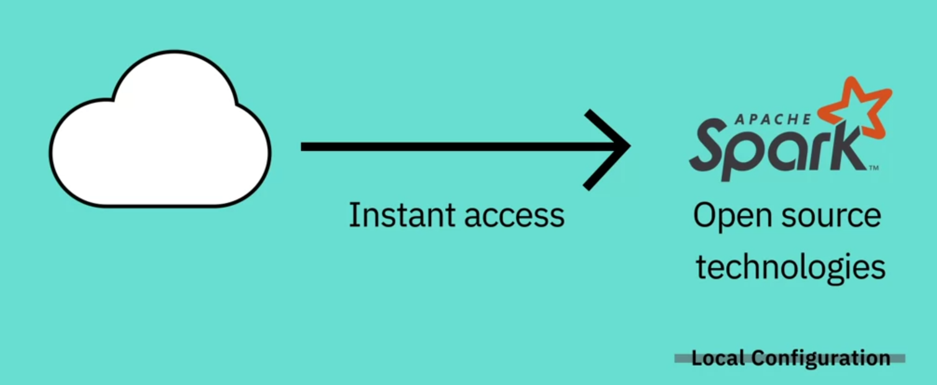

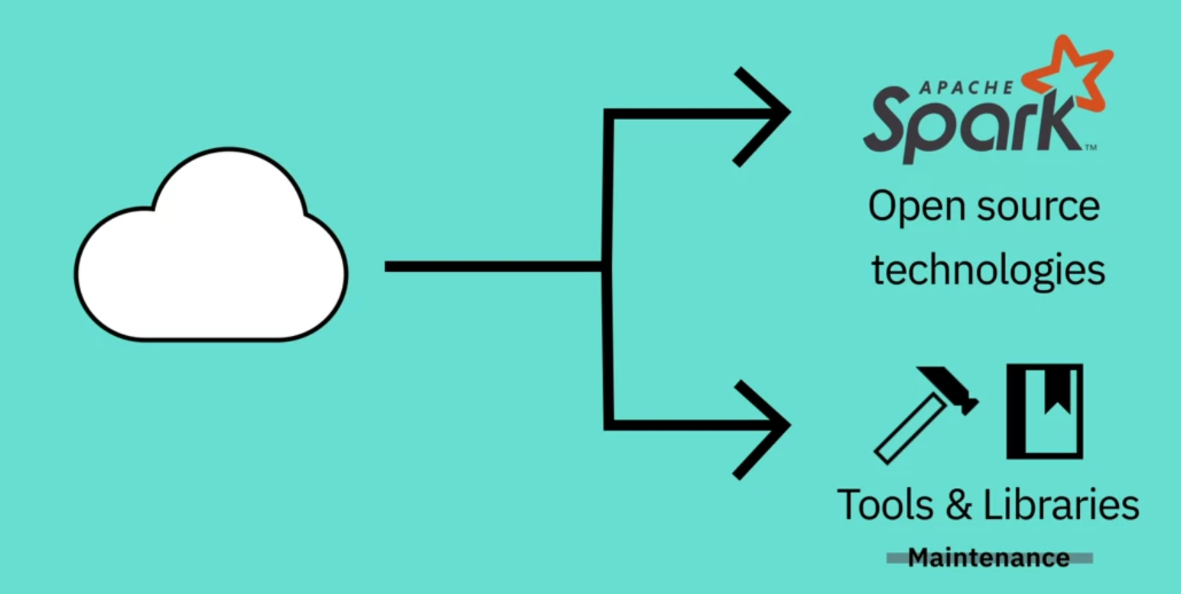

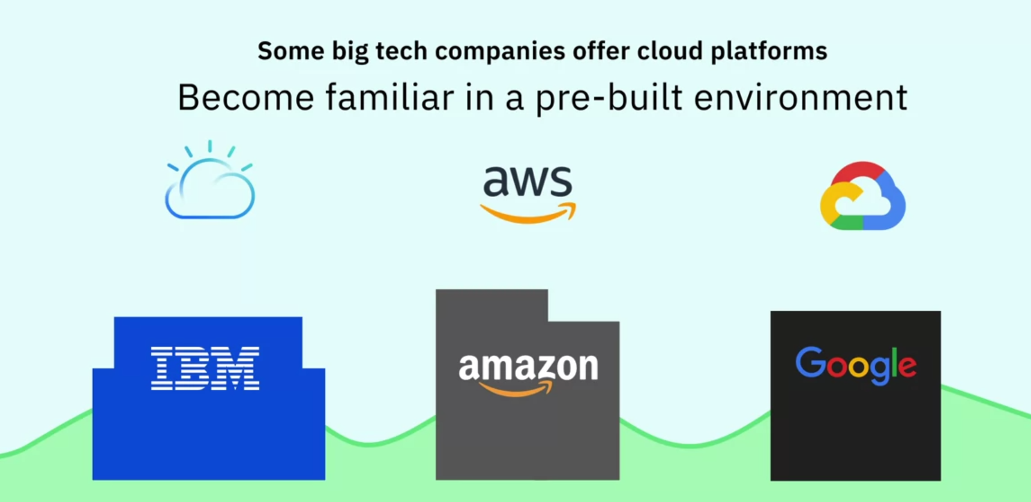

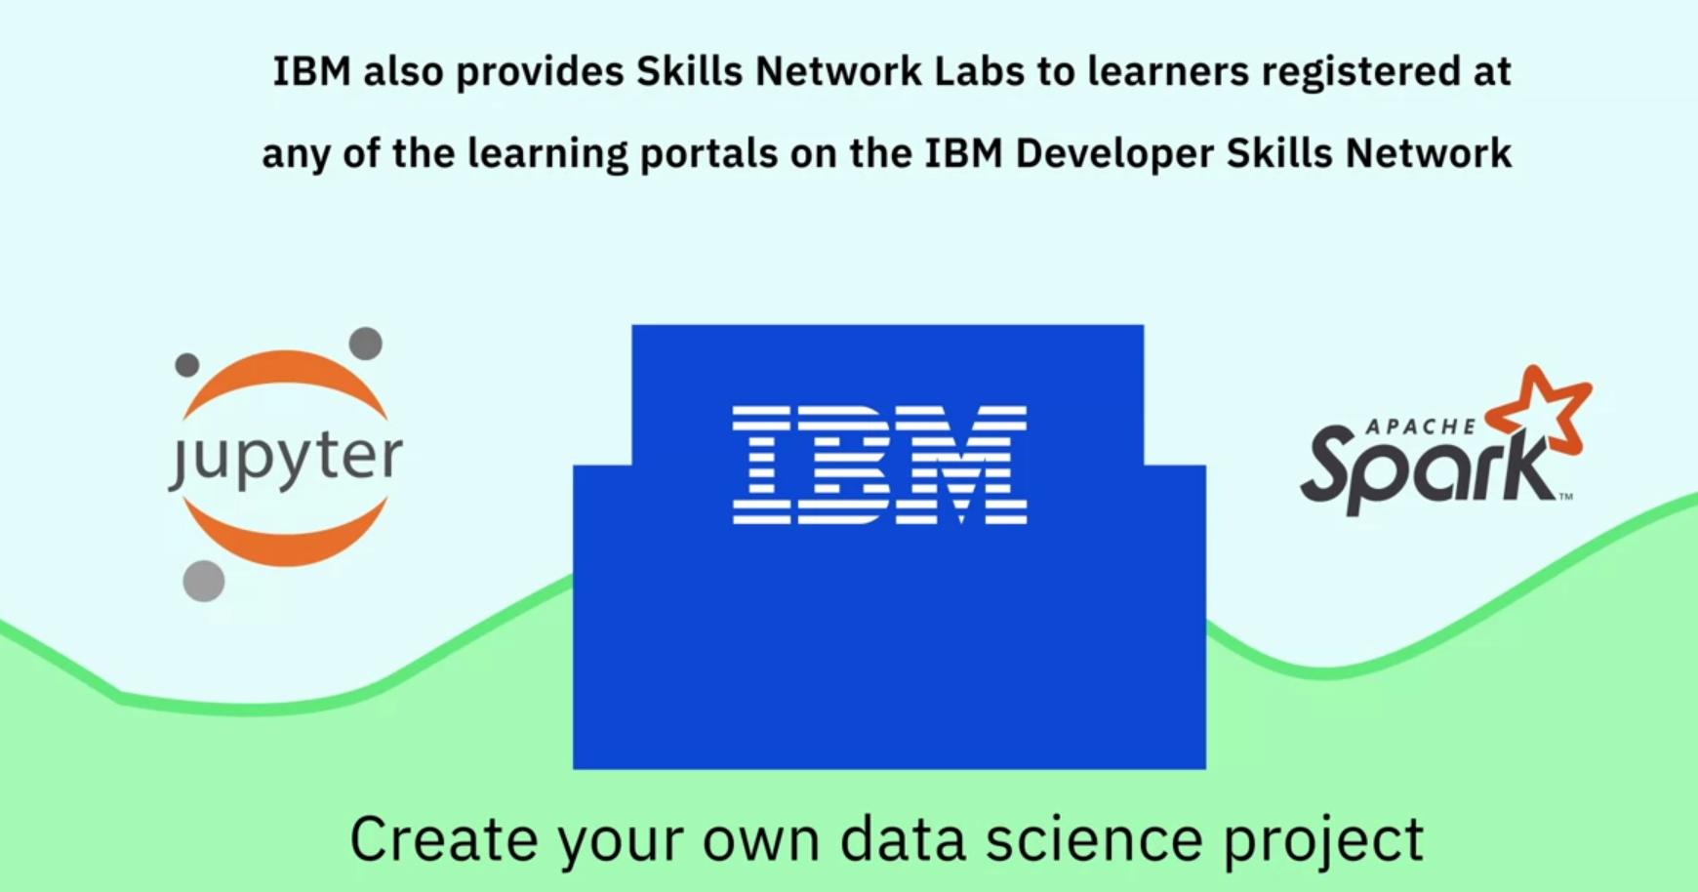

**Course Text Book: ‘Getting Started with Data Science’ Publisher: IBM Press; 1 edition (Dec 13 2015) Print.**

**Author: Murtaza Haider**

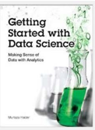

Prescribed Reading: Chapter 1 Pg. 12-15

### What Makes Someone a Data Scientist?

Now that you know what is in the book, it is time to put down some definitions. Despite their ubiquitous use, consensus evades the notions of Big data and Data Science. The question, **Who is a data scientist?** is very much alive and being contested by individuals, some of whom are merely interested in protecting their discipline or academic turfs. In this section, I attempt to address these controversies and explain Why a narrowly construed definition of either Big data or Data science will result in excluding hundreds of thousands of individuals who have recently turned to the emerging field.

**Everybody loves a data scientist,** wrote Simon Rogers (2012) in the Guardian. Mr. Rogers also traced the newfound love for number crunching to a quote by Google’s Hal Varian, who declared that ***the sexy job in the next ten years will be statisticians.***

Whereas Hal Varian named statisticians sexy, it is widely believed that what he really meant were data scientists. This raises several important questions:

* What is data science?
* How does it differ from statistics?
* What makes someone a data scientist?

In the times of big data, a question as simple as, ***What is data science?*** can result in many answers. In some cases, the diversity of opinion on these answers borders on hostility.

I define a data scientist as someone who finds solutions to problems by analyzing Big or small data using appropriate tools and then tells stories to communicate her findings to the relevant stakeholders. I do not use the data size as a restrictive clause. A data below a certain arbitrary threshold does not make one less of a data scientist. Nor is my definition of a data scientist restricted to particular analytic tools, such as machine learning. As long as one has a curious mind, fluency in analytics, and the ability to communicate the findings, I consider the person a data scientist.

I define data science as something that data scientists do. Years ago, as an engineering student at the University of Toronto, I was stuck With the question: What is engineering? I wrote my master’s thesis on forecasting housing prices and my doctoral dissertation on forecasting homebuilders’ choices related to What they build, when they build, and where they build new housing. In the civil engineering department, Others were working on designing buildings, bridges, tunnels, and worrying about the stability of slopes. My work, and that of my supervisor, was not your traditional garden-variety engineering. Obviously, I was repeatedly asked by others whether my research was indeed engineering.

When I shared these concerns with my doctoral supervisor, Professor Eric Miller, he had a laugh. Dr Miller spent a lifetime researching urban land use and transportation and had earlier earned a doctorate from MIT. “Engineering is what engineers do,” he responded. Over the next 17 years, I realized the wisdom in his statement. You first become an engineer by obtaining a degree and then registering with the local professional body that regulates the engineering profession. Now you are an engineer. You can dig tunnels; write software codes; design components of an iPhone or a supersonic jet. You are an engineer. And when you are leading the global response to a financial crisis in your role as the chief economist of the International Monetary Fund (IMF), as Dr Raghuram Rajan did, you are an engineer.

Professor Raghuram Rajan did his first degree in electrical engineering from the Indian Institute of Technology. He pursued economics in graduate studies, later became a professor at a prestigious university, and eventually landed at the IMF. He is currently serving as the 23rd Governor of the Reserve Bank of India. Could someone argue that his intellectual prowess is rooted only in his training as an economist and that the  
fundamentals he learned as an engineering student played no role in developing his problem-solving abilities?

Professor Rajan is an engineer. So are Xi Jinping, the President of the People’s Republic of China, and Alexis Tsipras, the Greek Prime Minister who is forcing the world to rethink the fundamentals of global economics. They might not be designing new circuitry, distillation equipment, or bridges, but they are helping build better societies and economies and there can be no better definition of engineering and  
engineers—that is, individuals dedicated to building better economies and societies.

So briefly, I would argue that data science is what data scientists do.

Others have many different definitions. In September 2015, a co-panelist at a meetup organized by BigDataUniversity.com in Toronto confined data science to machine learning. There you have it. If you are not using the black boxes that makeup machine learning, as per some experts in the field, you are not a data scientist. Even if you were to discover the cure to a disease threatening the lives of millions, turf-protecting  
colleagues will exclude you from the data science club.

Dr Vincent Granville (2014), an author on data science, offers certain thresholds to meet to be a data scientist. On pages 8 and 9 in Developing Analytic talent, Dr Granville describes the new data science professor as a non-tenured instructor at a non-traditional university, who publishes research results in  
online blogs, does not waste time writing grants, works from home, and earns more money than the traditional tenured professors. Suffice it to say that the thriving academic community of data scientists might disagree with Dr Granville.

Dr Granville uses restrictions on data size and methods to define what data science is. He defines a data scientist as one who can ***easily process a So-million-row data set in a couple of hours,*** and who distrusts (statistical) models. He distinguishes data science from statistics. Yet he lists algebra, calculus, and training in probability and statistics as necessary background ***to understand data science*** (page 4).

Some believe that big data is merely about crossing a certain threshold on data size or the number of observations, or is about the use of a particular tool, such as Hadoop. Such arbitrary thresholds on data size are problematic because, with innovation, even regular computers and off-the-shelf software have begun to manipulate very large data sets. Stata, a commonly used software by data scientists and statisticians, announced that one could now process between 2 billion to 24.4 billion rows using its desktop solutions. If Hadoop is the password to the big data club, Stata’s ability to process 24.4 billion rows, under certain limitations, has just gatecrashed that big data party.

It is important to realize that one who tries to set arbitrary thresholds to exclude others is likely to run into inconsistencies. The goal should be to define data science in a more exclusive, discipline- and platform-independent, size-free context where data-centric problem solving and the ability to weave strong narratives take center stage.

Given the controversy, I would rather consult others to see how they describe a data scientist. Why don’t we again consult the Chief Data Scientist of the United States? Recall Dr Patil told the Guardian newspaper in 2012 that a data scientist is that unique blend of skills that can both unlock the insights of data and tell a fantastic story via the data. What is admirable about Dr Patil’s definition is that it is inclusive of individuals of various academic backgrounds and training, and does not restrict the definition of a data scientist to a particular tool or subject it to a certain arbitrary minimum threshold of data size.

The other key ingredient for a successful data scientist is a behavioral trait: curiosity. A data scientist has to be one with a very curious mind, willing to spend significant time and effort to explore her hunches. In journalism, the editors call it having the nose for news. Not all reporters know where the news lies. Only  
those Who have the nose for news get the Story. Curiosity is equally important for data scientists as it is for journalists.

Rachel Schutt is the Chief Data Scientist at News Corp. She teaches a data science course at Columbia University. She is also the author of an excellent book, Doing Data Science. In an interview With the New York Times, Dr Schutt defined a data scientist as someone who is a part computer scientist, part software engineer, and part statistician (Miller, 2013). But that’s the definition of an average data scientist. “The best”, she contended, “tend to be really curious people, thinkers who ask good questions and are O.K. dealing with unstructured situations and trying to find structure in them.”

In this lesson, you have learned:

* The typical work day for a Data Scientist varies depending on what type of project they are working on.
* Many algorithms are used to bring out insights from data.
* Accessing algorithms, tools, and data through the Cloud enables Data Scientists to stay up-to-date and collaborate easily.

**Week 2**

**Big Data and Data Mining**

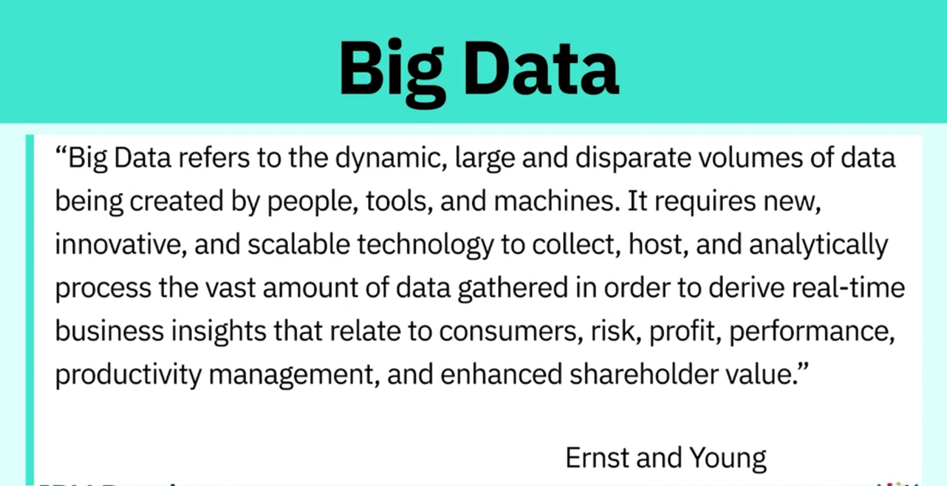

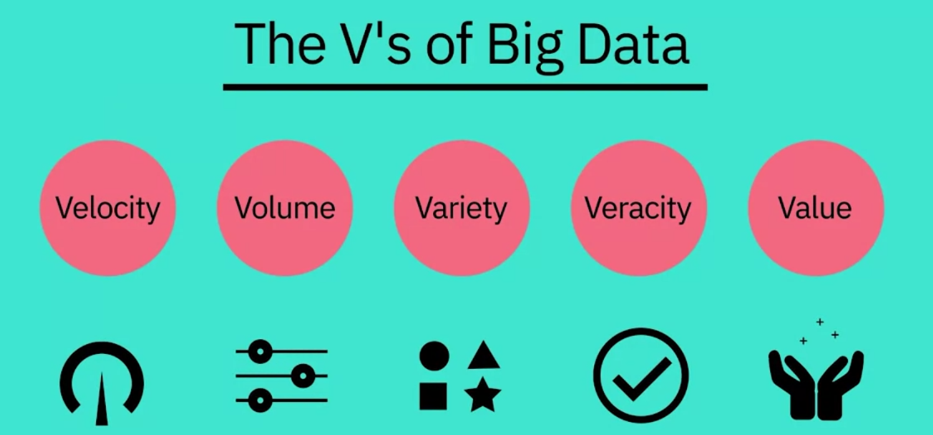

* 1. Velocity: speed at which data accumulates.
  2. Volume: scale of the data

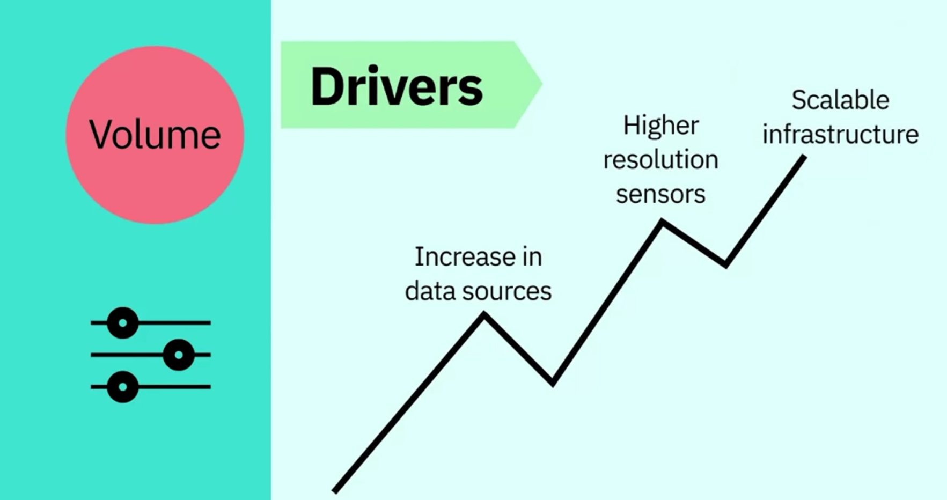

* 1. Variety: diversity of data; variety also reflects that data comes from various sources (machines, people and processes).

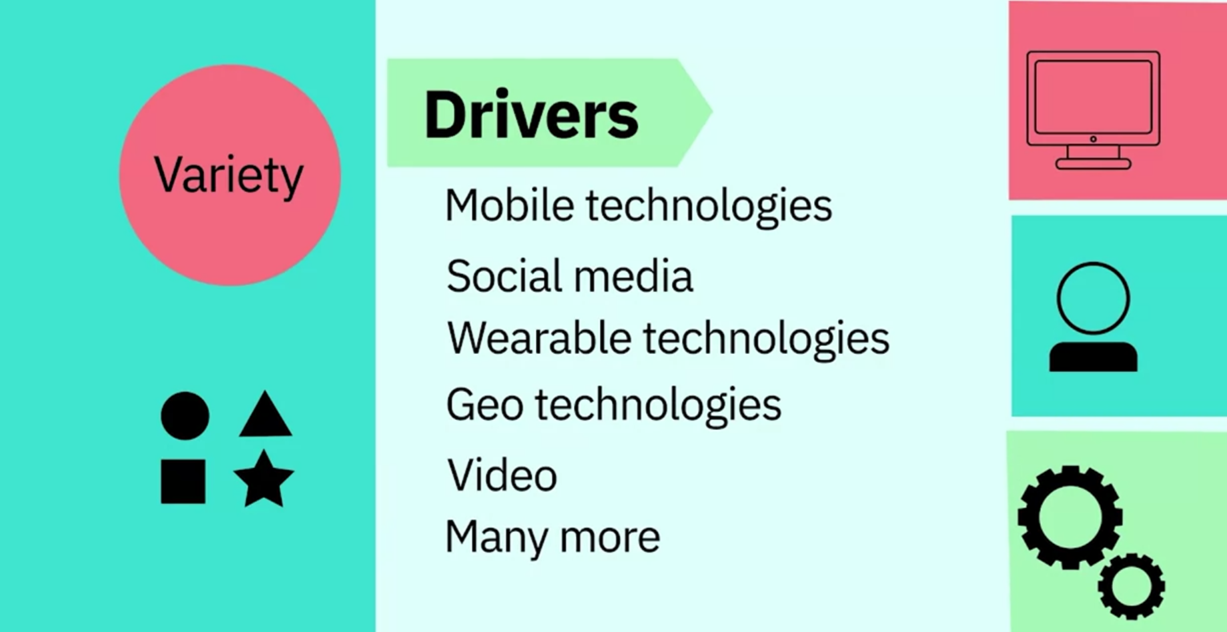

* 1. Veracity: quality and origin of data and conformity to facts and accuracy.

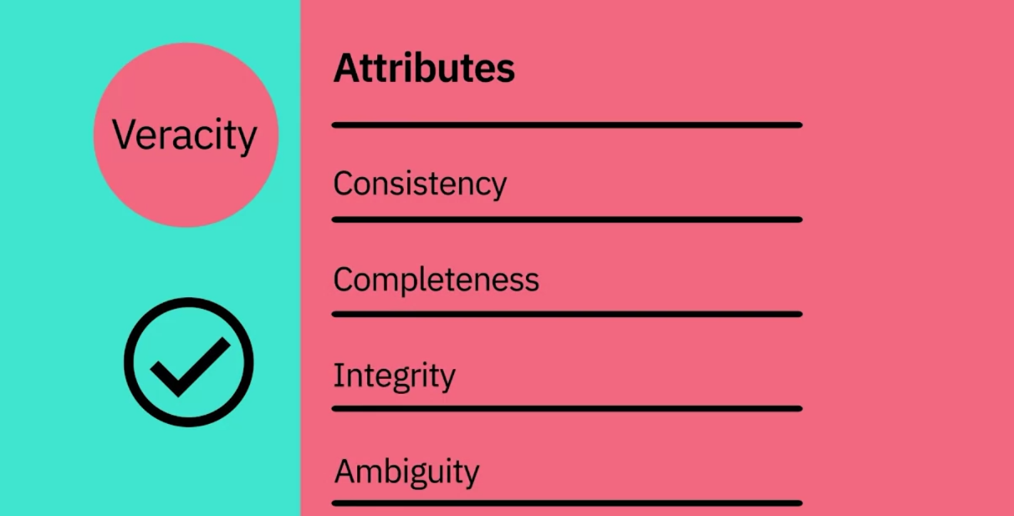

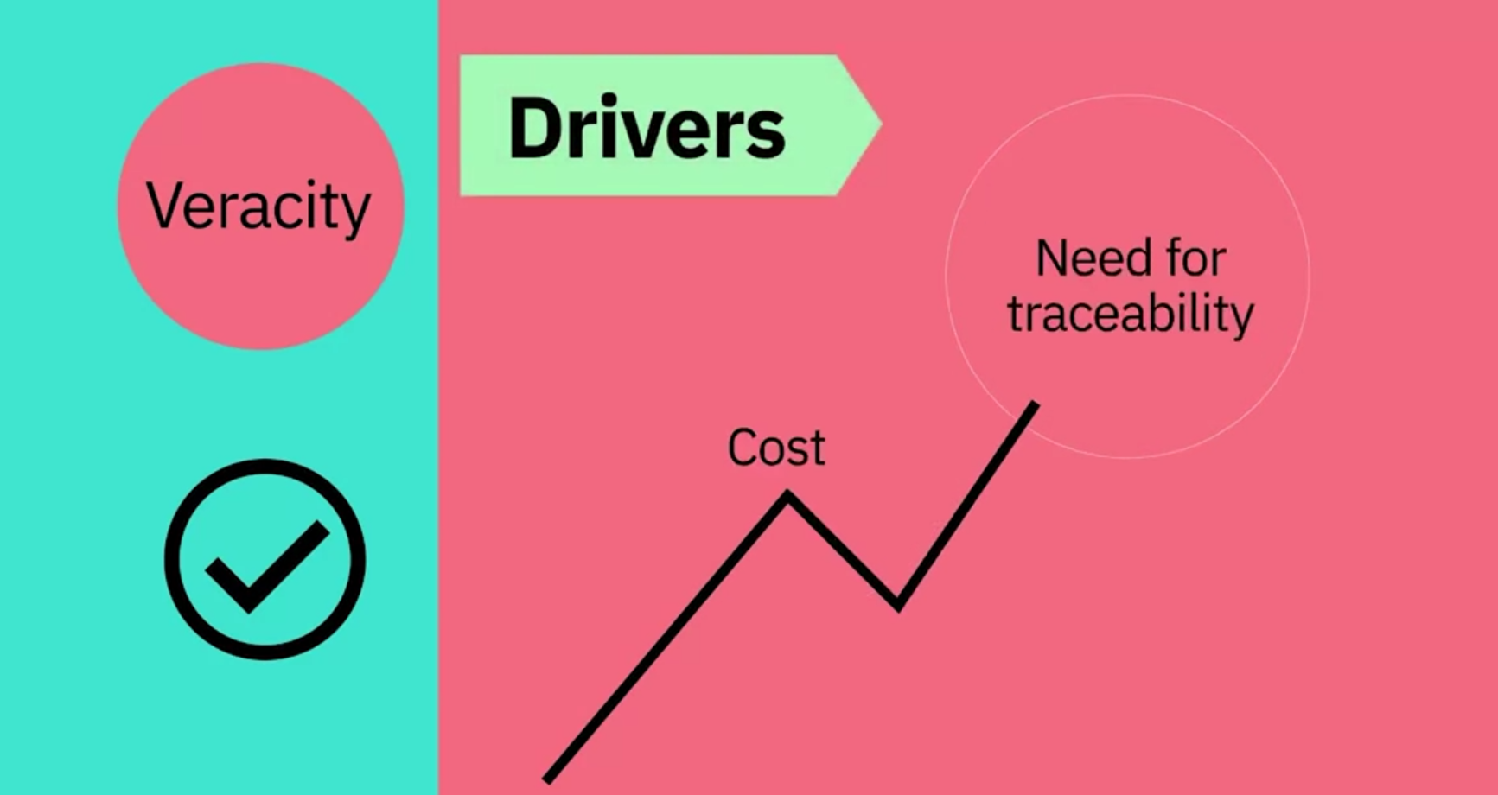

* 1. Value: our ability and need to turn data into value. The main reason that people invest time to understand Big Data is to derive value from it.

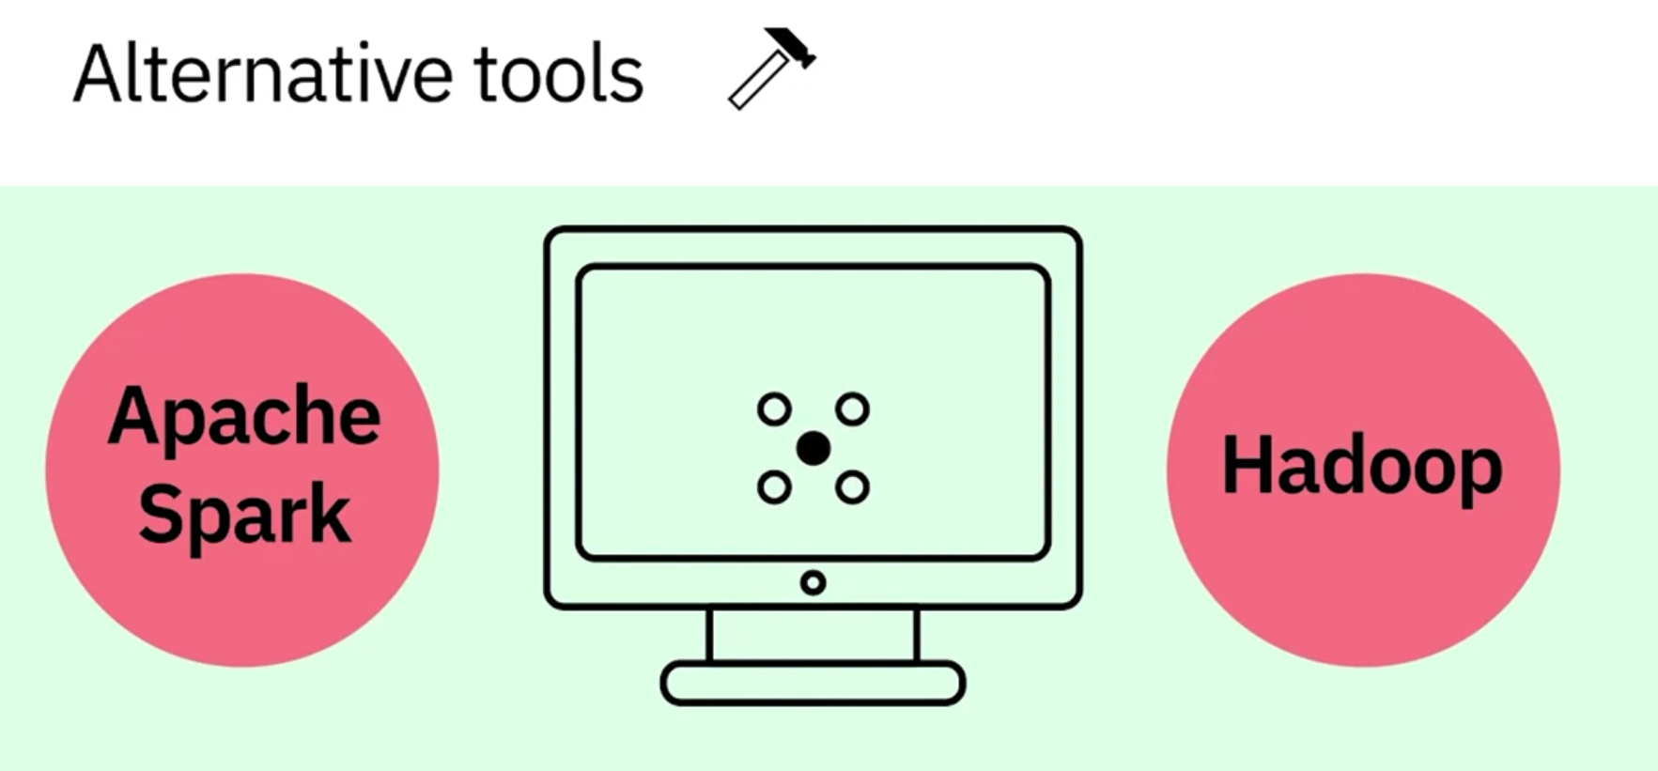

To analyze data.

According to Dr. White, most of the components of data science, such as probability, statistics, linear algebra, and programming, have been around for many decades but now we have the computational capabilities to apply combine them and come up with new techniques and learning algorithms.

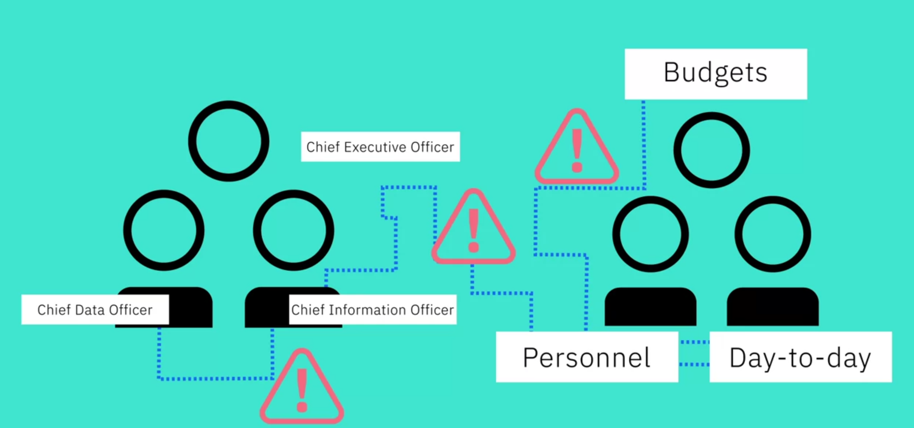

According to Dr. White, his students, who are mostly aspiring data scientists, need to learn many tools such as Python, UNIX commands, pandas, and Jupyter notebook.

Big data was started by Google when Google tried to figure out how how to solve their PageRank algorithm. Big data is data that is large enough and has enough volume and velocity that you cannot handle it with traditional data database systems.

**Course Text Book: ‘Getting Started with Data Science’ Publisher: IBM Press; 1 edition (Dec 13 2015) Print.**

**Author: Murtaza Haider**

Prescribed Reading: Chapter 12 Pg. 529-531

## Establishing Data Mining Goals

The first step in data mining requires you to set up goals for the exercise. Obviously, you must identify the key questions that need to be answered. However, going beyond identifying the key questions are the concerns about the costs and benefits of the exercise. Furthermore, you must determine, in advance, the expected level of accuracy and usefulness of the results obtained from data mining. If money were no object, you could throw as many funds as necessary to get the answers required. However, the cost-benefit trade-off is always instrumental in determining the goals and scope of the data mining exercise. The level of accuracy expected from the results also influences the costs. High levels of accuracy from data mining would cost more and vice versa. Furthermore, beyond a certain level of accuracy, you do not gain much from the exercise, given the diminishing returns. Thus, the cost-benefit trade-offs for the desired level of accuracy are important considerations for data mining goals.

## Selecting Data

The output of a data-mining exercise largely depends upon the quality of data being used. At times, data are readily available for further processing. For instance, retailers often possess large databases of customer purchases and demographics. On the other hand, data may not be readily available for data mining. In such cases, you must identify other sources of data or even plan new data collection initiatives, including surveys. The type of data, its size, and frequency of collection have a direct bearing on the cost of data mining exercise. Therefore, identifying the right kind of data needed for data mining that could answer the questions at reasonable costs is critical.

## Preprocessing Data

Preprocessing data is an important step in data mining. Often raw data are messy, containing erroneous or irrelevant data. In addition, even with relevant data, information is sometimes missing. In the preprocessing stage, you identify the irrelevant attributes of data and expunge such attributes from further consideration. At the same time, identifying the erroneous aspects of the data set and flagging them as such is necessary. For instance, human error might lead to inadvertent merging or incorrect parsing of information between columns. Data should be subject to checks to ensure integrity. Lastly, you must develop a formal method of dealing with missing data and determine whether the data are missing randomly or systematically.

If the data were missing randomly, a simple set of solutions would suffice. However, when data are missing in a systematic way, you must determine the impact of missing data on the results. For instance, a particular subset of individuals in a large data set may have refused to disclose their income. Findings relying on an individual's income as input would exclude details of those individuals whose income was not reported. This would lead to systematic biases in the analysis. Therefore, you must consider in advance if observations or variables containing missing data be excluded from the entire analysis or parts of it.

## Transforming Data

After the relevant attributes of data have been retained, the next step is to determine the appropriate format in which data must be stored. An important consideration in data mining is to reduce the number of attributes needed to explain the phenomena. This may require transforming data reduction algorithms, such as Principal Component Analysis (demonstrated and explained later in the chapter), can reduce the number of attributes without a significant loss in information. In addition, variables may need to be transformed to help explain the phenomenon being studied. For instance, an individual's income may be recorded in the data set as wage income; income from other sources, such as rental properties; support payments from the government, and the like. Aggregating income from all sources will develop a representative indicator for the individual income.

Often you need to transform variables from one type to another. It may be prudent to transform the continuous variable for income into a categorical variable where each record in the database is identified as low, medium, and high-income individual. This could help capture the non-linearities in the underlying behaviors.

## Storing Data

The transformed data must be stored in a format that makes it conducive for data mining. The data must be stored in a format that gives unrestricted and immediate read/write privileges to the data scientist. During data mining, new variables are created, which are written back to the original database, which is why the data storage scheme should facilitate efficiently reading from and writing to the database. It is also important to store data on servers or storage media that keeps the data secure and also prevents the data mining algorithm from unnecessarily searching for pieces of data scattered on different servers or storage media. Data safety and privacy should be a prime concern for storing data.

## Mining Data

After data is appropriately processed, transformed, and stored, it is subject to data mining. This step covers data analysis methods, including parametric and non-parametric methods, and machine-learning algorithms. A good starting point for data mining is data visualization. Multidimensional views of the data using the advanced graphing capabilities of data mining software are very helpful in developing a preliminary understanding of the trends hidden in the data set.

Later sections in this chapter detail data mining algorithms and methods.

## Evaluating Mining Results

After results have been extracted from data mining, you do a formal evaluation of the results. Formal evaluation could include testing the predictive capabilities of the models on observed data to see how effective and efficient the algorithms have been in reproducing data. This is known as an "in-sample forecast". In addition, the results are shared with the key stakeholders for feedback, which is then incorporated in the later iterations of data mining to improve the process.

Data mining and evaluating the results becomes an iterative process such that the analysts use better and improved algorithms to improve the quality of results generated in light of the feedback received from the key stakeholders.

Principal Component Analysis is an example of a data reduction algorithm.

After the data are appropriately processed, transformed, and stored, machine learning is a good starting point for data mining.

In-sample forecast is the process of formally evaluating the predictive capabilities of the models developed using observed data to see how effective the algorithms are in reproducing data.

* How Big Data is defined by the Vs: Velocity, Volume, Variety, Veracity, and Value.
* How Hadoop and other tools, combined with distributed computing power, are used to handle the demands of Big Data.
* What skills are required to analyse Big Data.
* About the process of Data Mining, and how it produces results.

**Deep Learning and Machine Learning**

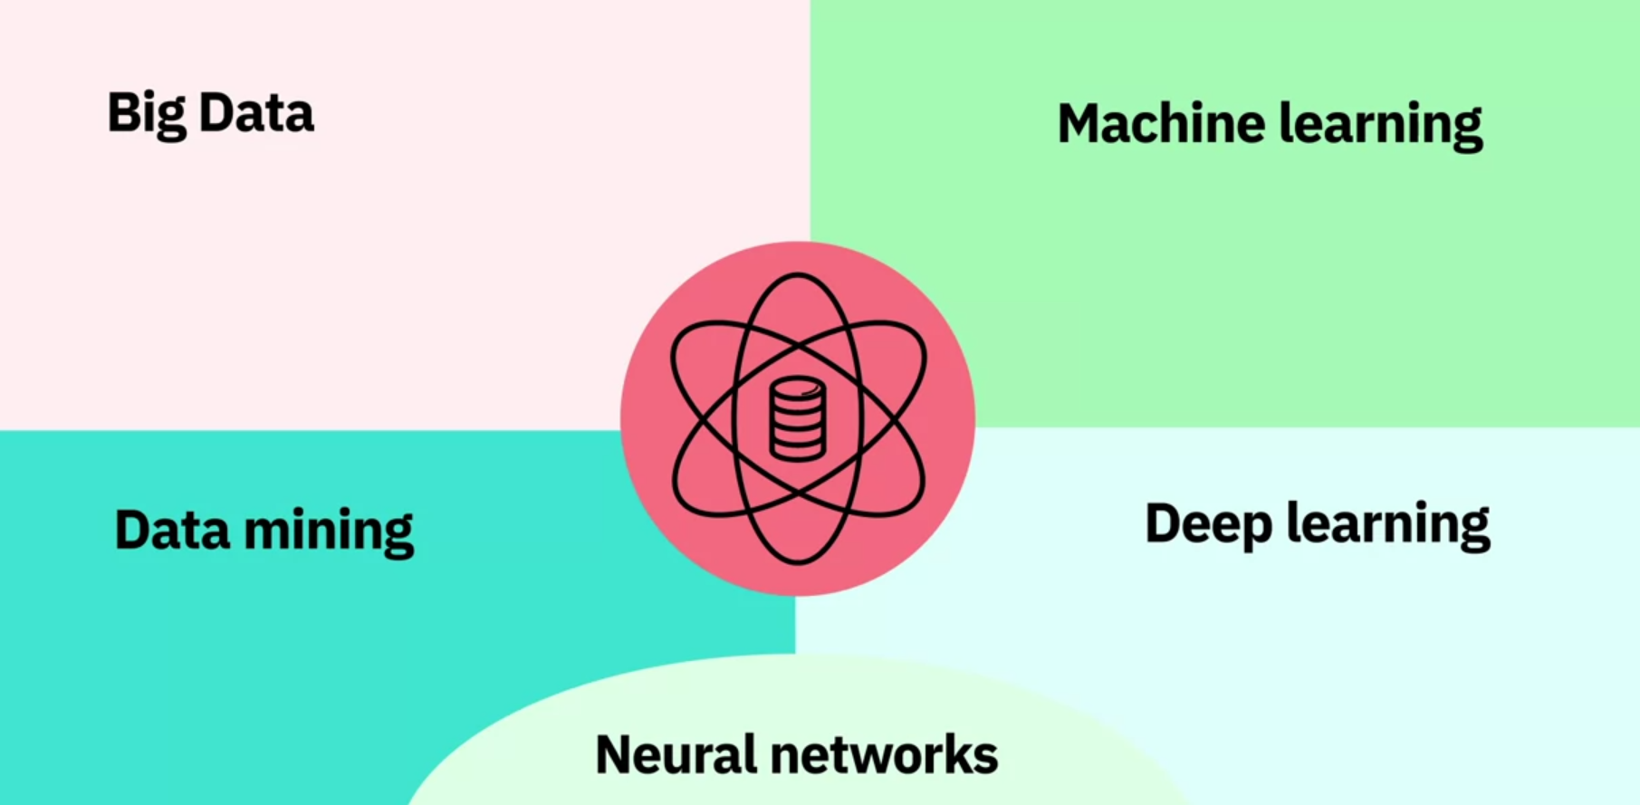

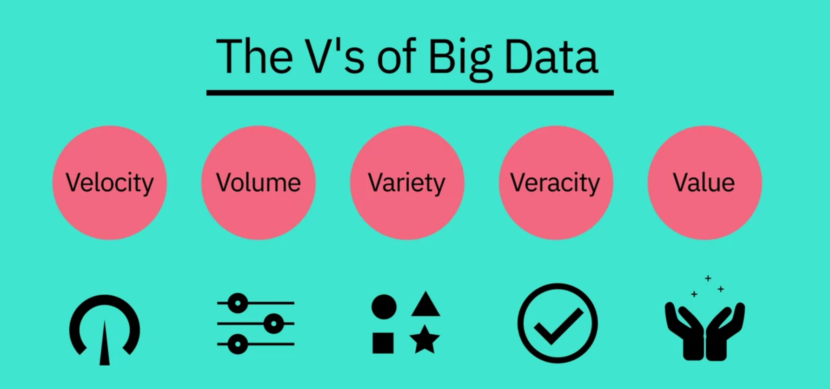

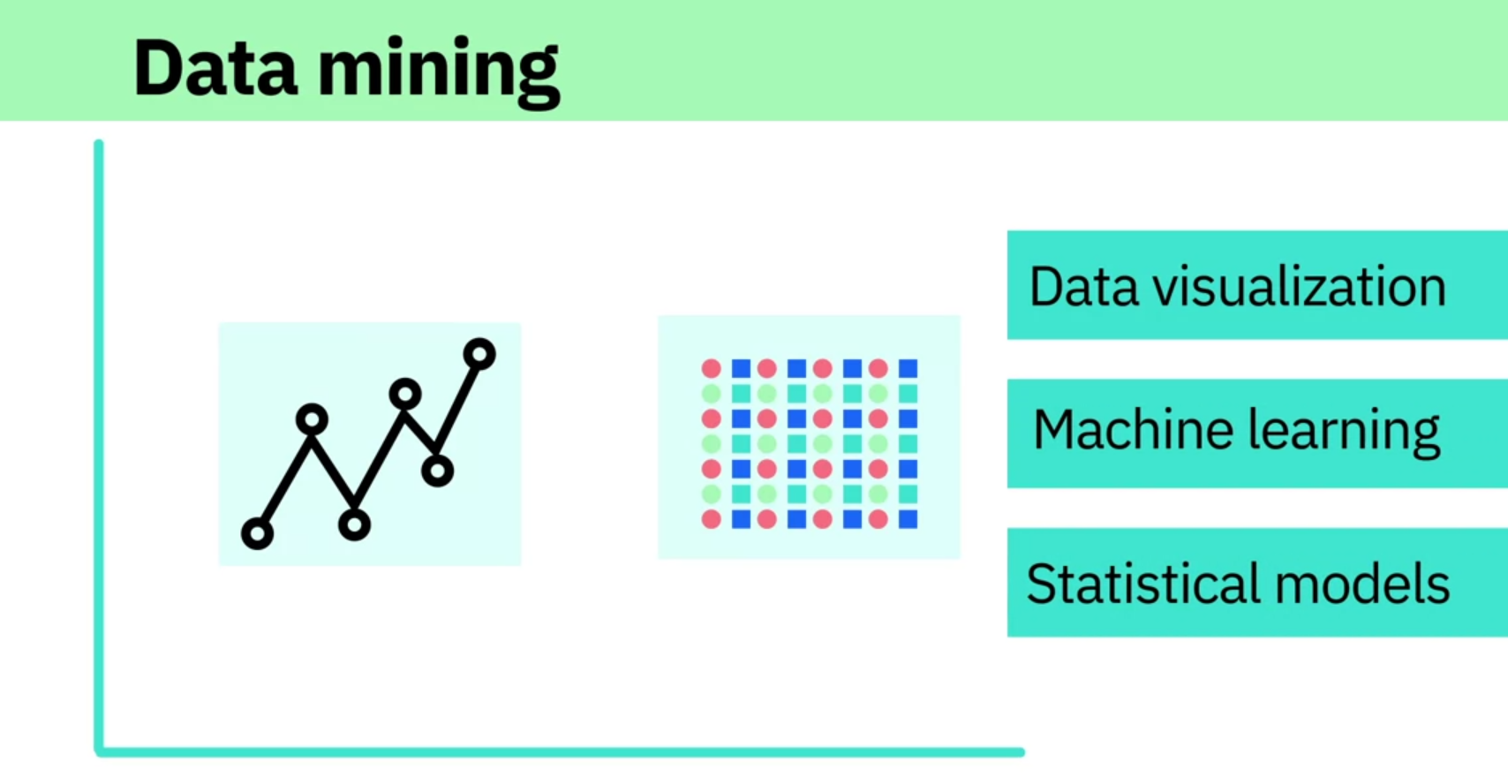

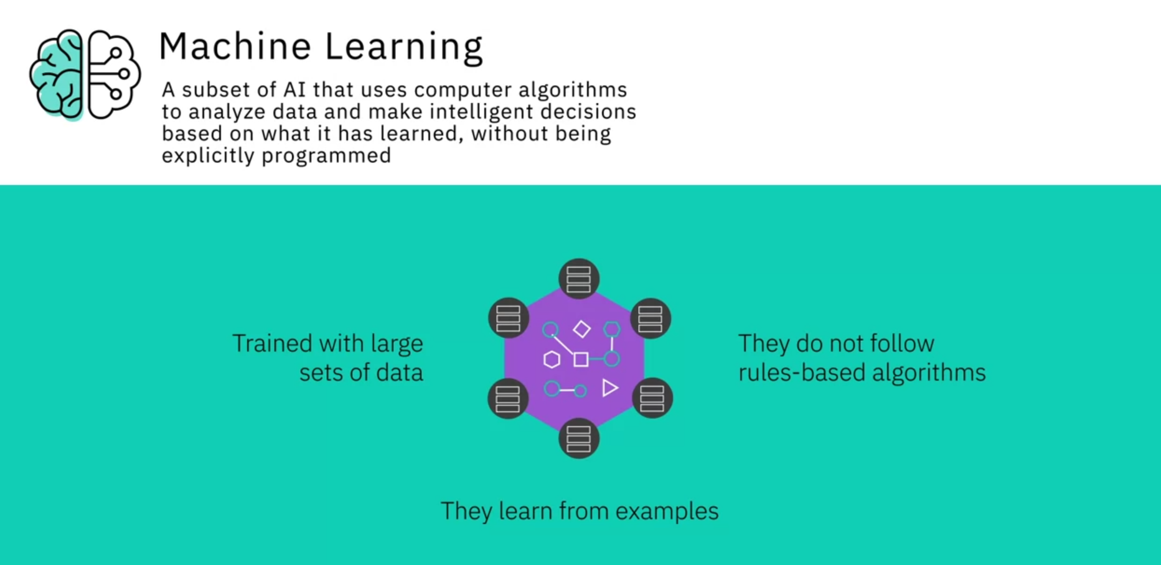

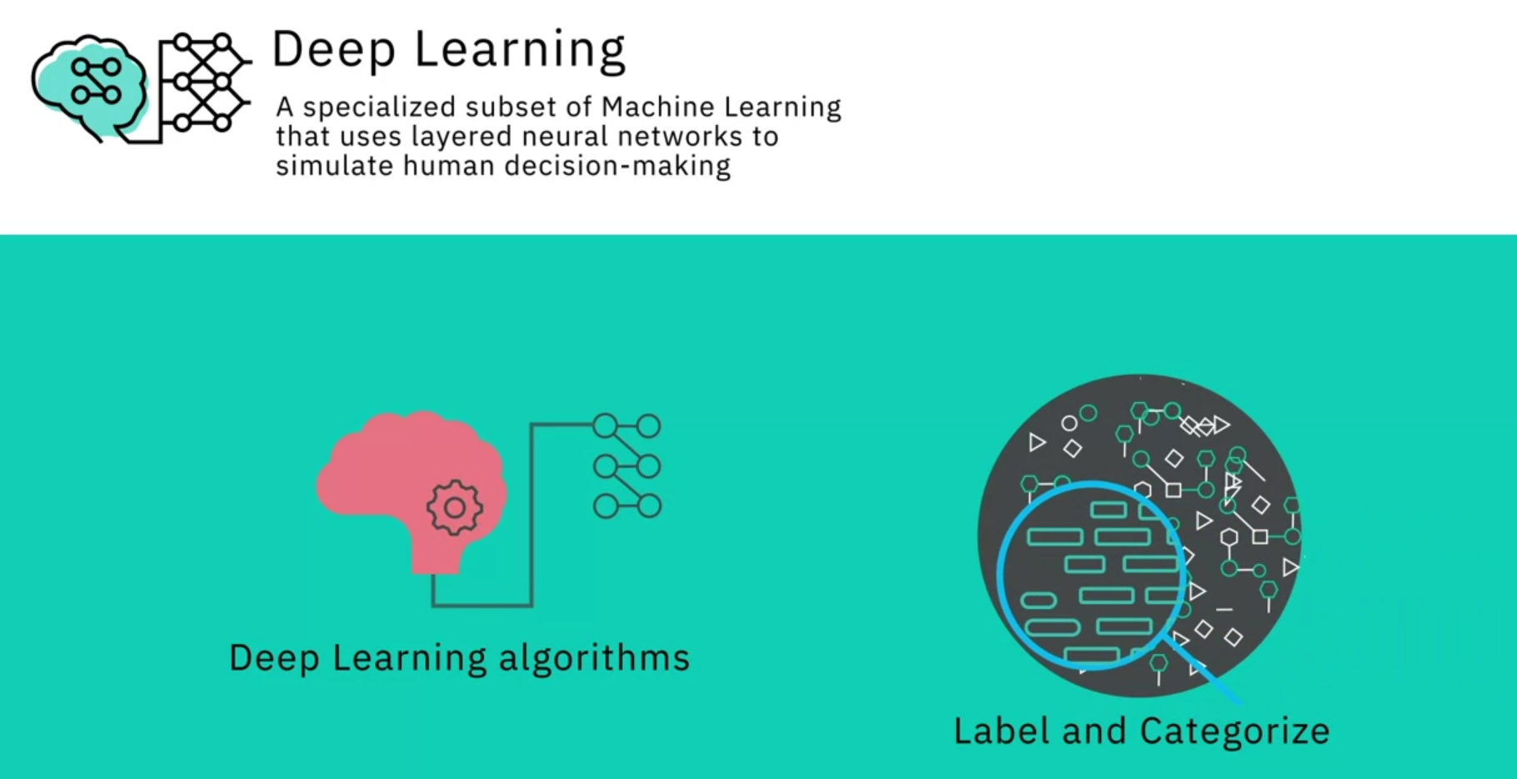

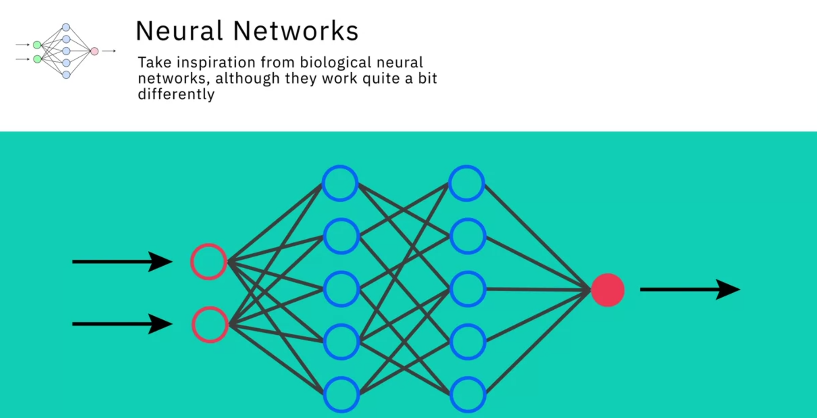

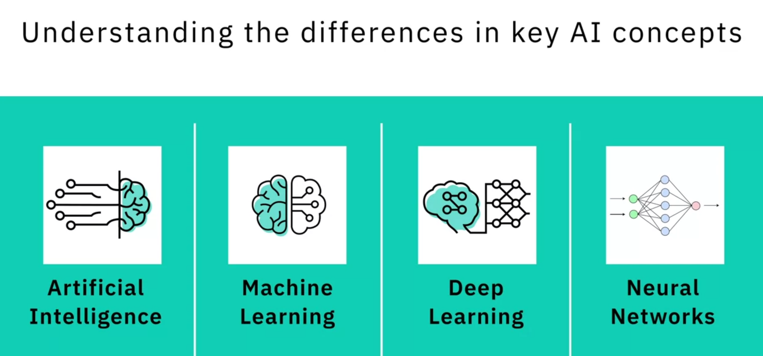

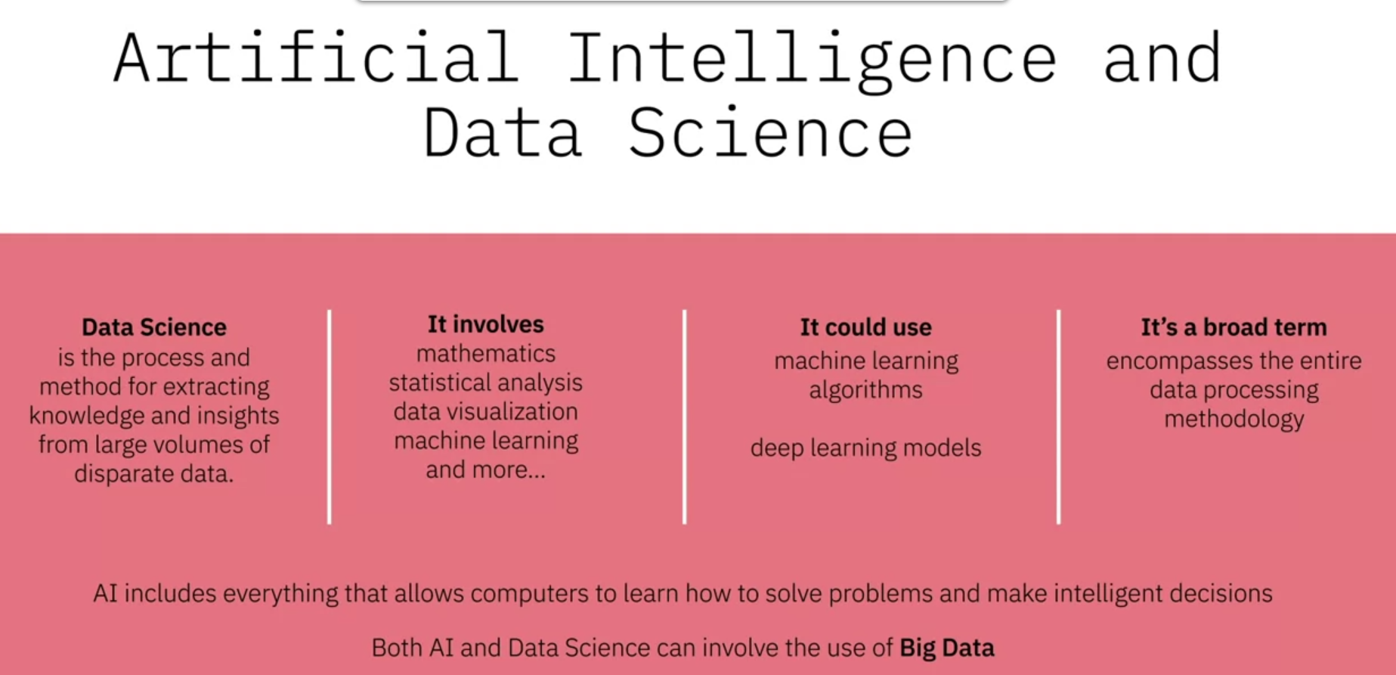

**Course Text Book: ‘Getting Started with Data Science’ Publisher: IBM Press; 1 edition (Dec 13 2015) Print.**

**Author: Murtaza Haider**



Prescribed Reading: Chapter 7 Pg. 235-236

## Chapter 7. Why Tall Parents Don't Have Even Taller Children

You might have noticed that taller parents often have tall children who are not necessarily taller than their parents and that's a good thing. This is not to suggest that children born to tall parents are not necessarily taller than the rest. That may be the case, but they are not necessarily taller than their own "tall" parents. Why I think this to be a good thing requires a simple mental simulation. Imagine if every successive generation born to tall parents were taller than their parents, in a matter of a couple of millennia, human beings would become uncomfortably tall for their own good, requiring even bigger furniture, cars, and planes.

Sir Frances Galton in 1886 studied the same question and landed upon a statistical technique we today know as regression models. This chapter explores the workings of regression models, which have become the workhorse of statistical analysis. In almost all empirical pursuits of research, either in the academic or professional fields, the use of regression models, or their variants, is ubiquitous. In medical science, regression models are being used to develop more effective medicines, improve the methods for operations, and optimize resources for small and large hospitals. In the business world, regression models are at the forefront of analyzing consumer behavior, firm productivity, and competitiveness of public and private­ sector entities.

I would like to introduce regression models by narrating a story about my Master's thesis. I believe that this story can help explain the utility of regression models.

## The Department of Obvious Conclusions

In 1999, I finished my Masters' research on developing hedonic price models for residential real estate properties. It took me three years to complete the project involving 500,000 real estate transactions. As I was getting ready for the defense, my wife generously offered to drive me to the university. While we were on our way, she asked, "Tell me, what have you found in your research?". I was delighted to be finally asked to explain what I have been up to for the past three years. "Well, I have been studying the determinants of housing prices. I have found that larger homes sell for more than smaller homes," I told my wife with a triumphant look on my face as I held the draft of the thesis in my hands.

We were approaching the on-ramp for a highway. As soon as I finished the sentence, my wife suddenly turned the car to the shoulder and applied brakes. As the car stopped, she turned to me and said: "I can't believe that they are giving you a Master's degree for finding just that. I could have told you that larger homes sell for more than smaller homes."

At that very moment, I felt like a professor who taught at the department of obvious conclusions. How can I blame her for being shocked that what is commonly known about housing prices will earn me a Master's degree from a university of high repute?

I requested my wife to resume driving so that I could take the next ten minutes to explain to her the intricacies of my research. She gave me five minutes instead, thinking this may not require even that. I settled for five and spent the next minute collecting my thoughts. I explained to her that my research has not just found the correlation between housing prices and the size of housing units, but I have also discovered the magnitude of those relationships. For instance, I found that all else being equal, a term that I explain later in this chapter, an additional washroom adds more to the housing price than an additional bedroom. Stated otherwise, the marginal increase in the price of a house is higher for an additional washroom than for an additional bedroom. I found later that the real estate brokers in Toronto indeed appreciated this finding. I also explained to my wife that proximity to transport infrastructure, such as subways, resulted in higher housing prices. For instance, houses situated closer to subways sold for more than did those situated farther away. However, houses near freeways or highways sold for less than others did. Similarly, I also discovered that proximity to large shopping centers had a nonlinear impact on housing prices. Houses located very close (less than 2.5 km) to the shopping centers sold for less than the rest. However, houses located closer (less than 5 km, but more than 2.5 km) to the shopping center sold for more than did those located farther away. I also found that the housing values in Toronto declined with distance from downtown.

As I explained my contributions to the study of housing markets, I noticed that my wife was mildly impressed. The likely reason for her lukewarm reception was that my findings confirmed what we already knew from our everyday experience. However, the real value added by the research rested in quantifying the magnitude of those relationships.

## Why Regress?

A whole host of questions could be put to regression analysis. Some examples of questions that regression (hedonic) models could address include:

* How much more can a house sell for an additional bedroom?
* What is the impact of lot size on housing price?
* Do homes with brick exteriors sell for less than homes with stone exteriors?
* How much does a finished basement contribute to the price of a housing unit?
* Do houses located near high-voltage power lines sell for more or less than the rest?
* The differences between some common Data Science terms, including Deep Learning and Machine Learning.
* Deep Learning is a type of Machine Learning that simulates human decision-making using neural networks.
* Machine Learning has many applications, from recommender systems that provide relevant choices for customers on commercial websites, to detailed analysis of financial markets.
* How to use regression to analyze data.

**Week 3**

**Data Science in Business**

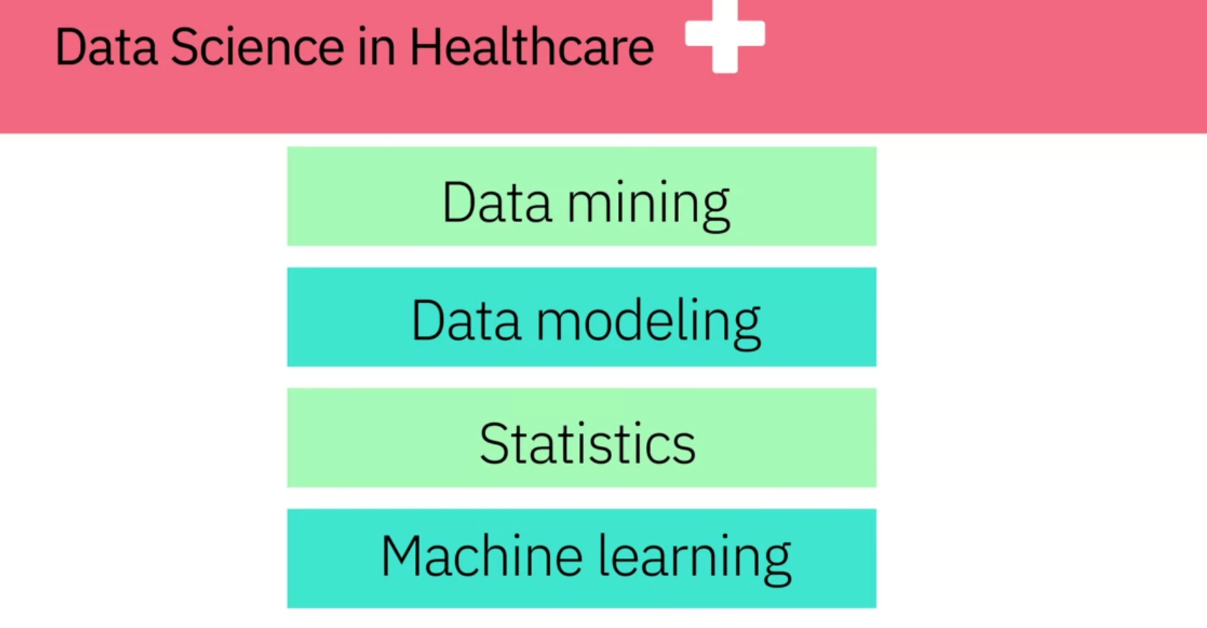

**Course Text Book: ‘Getting Started with Data Science’ Publisher: IBM Press; 1 edition (Dec 13 2015) Print.**

**Author: Murtaza Haider**



Prescribed Reading: Chapter 3 Pg. 52-53

### The Final Deliverable

The ultimate purpose of analytics is to communicate findings to the concerned who might use these insights to formulate policy or strategy. Analytics summarize findings in tables and plots. The data scientist should then use the insights to build the narrative to communicate the findings. In academia, the final deliverable is in the form of essays and reports. Such deliverables are usually 1,000 to 7,000 words in length. In consulting and business, the final deliverable takes on several forms. It can be a small document of fewer than 1,500 words illustrated with tables and plots, or it could be a comprehensive document comprising several hundred pages. Large consulting firms, such as McKinsey and Deloitte,I routinely generate analytics-driven reports to communicate their findings and, in the process, establish their expertise in specific knowledge domains.

Let's review the "United States Economic Forecast", a publication by the Deloitte University Press. This document serves as a good example for a deliverable that builds narrative from data and analytics. The 24-page report focuses on the state of the U.S. economy as observed in December 2014. The report opens with a **grabber** highlighting the fact that contrary to popular perception, the economic and job growth has been quite robust in the United States. The report is not merely a statement of facts.

In fact, it is a carefully crafted report that cites Voltaire and follows a distinct theme. The report focuses on the **good news** about the U.S. economy. These include the increased investment in manufacturing equipment in the U.S. and the likelihood of higher consumer consumption resulting from lower oil prices.

The Deloitte report uses time series plots to illustrate trends in markets. The GDP growth chart shows how the economy contracted during the Great Recession and has rebounded since then. The graphic presents four likely scenarios for the future. Another plot shows the changes in consumer spending. The accompanying narrative focuses on income inequality in the U.S. and refers to Thomas Pikkety's book on the same. The Deloitte report mentions many consumers did not experience an increase in their real incomes over the years, while they still maintained their level of spending. Other graphics focused on housing, business, and government sectors, international trade, labor, and financial markets, and prices. The appendix carries four tables documenting data for the four scenarios discussed in the report.

Deloitte's "United States Economic Forecast" serves the very purpose that its authors intended. The report uses data and analytics to generate the likely economic scenarios. It builds a powerful narrative in support of the thesis statement that the U.S. economy is doing much better than most would like to believe. At the same time, the report shows Deloitte to be a competent firm capable of analyzing economic data and prescribing strategies to cope with the economic challenges.

Now consider if we were to exclude the narrative from this report and presented the findings as a deck of PowerPoint slides with eight graphics and four tables. The PowerPoint slides would have failed to communicate the message that the authors carefully crafted in the report citing Piketty and Voltaire. I consider Deloitte's report a good example of storytelling with data and encourage you to read the report to decide for yourself whether the deliverable would have been equally powerful without the narrative.

Now, let us work backward from the Deloitte report. Before the authors started their analysis, they must have discussed the scope of the final deliverable. They would have deliberated the key message of the report and then looked for the data and analytics they needed to make their case. The initial planning and conceptualizing of the final deliverable is therefore extremely important for producing a compelling document. Embarking on analytics, without due consideration to the final deliverable, is likely to result in a poor-quality document where the analytics and narrative would struggle to blend.

**Summary**

* Data Science helps physicians provide the best treatment for their patients, and helps meteorologists predict the extent of local weather events, and can even help predict natural disasters like earthquakes and tornadoes.
* That companies can start on their data science journey by capturing data. Once they have data, they can begin analysing it.
* Some ways that data is generated by consumers.
* How businesses like Netflix, Amazon, UPs, Google, and Apple use the data generated by their consumers and employees.
* The purpose of the final deliverable of a Data Science project is to communicate new information and insights from the data analysis to key decision-makers.

**Careers and Recruiting in Data Science**

According to Dr. White, if someone is coming into a data science team, the first skills they would need are:

* Knowing some algebra and some calculus.
* Knowing basic probability and some basic statistics.
* Understanding relational databases.
* Knowing how to program, at least have some computational thinking.

Curiosity is one of the most important skills that a data scientist should possess along with a sense of humor and story telling.

When hiring a data scientist, you need to ensure that the candidate is passionate about your field of work. A brilliant data scientist who is passionate about the field of IT won't necessary excel in the field of healthcare if they are not passionate about it.

From a skills point of view, let's focus on the technical skills and in that case, first thing would be what kind of a technical platform would you like to adopt? Let's say you want to work in a structured data environment and let's say you want to work in market research. Then the type of skills you need are slightly different than someone who would like to work in big data environments. If you want to work in the traditional market research data, structure data environment, your skills should be some statistical knowledge and some knowledge of basic statistical algorithms, maybe some machine learning algorithms. And these are the tools that you would like to develop. If you want to work in big data, then there's the other aspect of it and that is to be able to store data. So you start with the expertise in storing large amounts of data. And then you look into platforms that allow you to do that. The next step would be to be able to manipulate large amounts of data, and the final step would be to apply algorithms to those large sets of data. So it's a three-step process. But most likely it starts, most importantly, it starts with where you would like to be, in what field, in what domain. In terms of platforms, let's you want to be in the traditional predictive analytics environment, and you're not working with big data, then R or Stata, or Python would be your tools. If you're working mostly with unstructured data, then Python is most suitable than R. If you're working with big data, then Hadoop and Spark are the environments that you will be working with. So it all depends upon where you would like to be and what kind of work excites you and then you pick your tools. In addition to technical skills, the second aspect of the data science is to have the ability to communicate. The communication skills or presentation skills. I call them story telling skills, that is that you have your analysis done, now can you tell a great story from it? If you have a very large table, can you synthesize this and make it more appealing that when it goes on the screen, or is it part of a document that it just speaks? It sings the findings and the reader just gets it right there. So the ability to present your findings, either verbally, or in a presentation, or in a document. So those communication and presentation skills are equally important as the technical skills are. When you have a grading side, when you're presenting your results, imagine you're driving on a mountain and then there's a sharp turn. And you can't see what's beyond the turn. And then you make that turn and then suddenly, you see a tremendous valley in front of you. And this great sense of awe, that I didn't know that, right? So when you present your findings and you have this great finding and you communicate it well, this is what people feel because they were not expecting it. They were not aware of it, and then this great sense of happiness that now I know. And I didn't know this, now I know. And then it empowers them, it gives them ideas, what they can do with this knowledge, this new insight. It's a great sense of joy. And you are able as a data scientist, you are able to share with your clients because you enabled it.

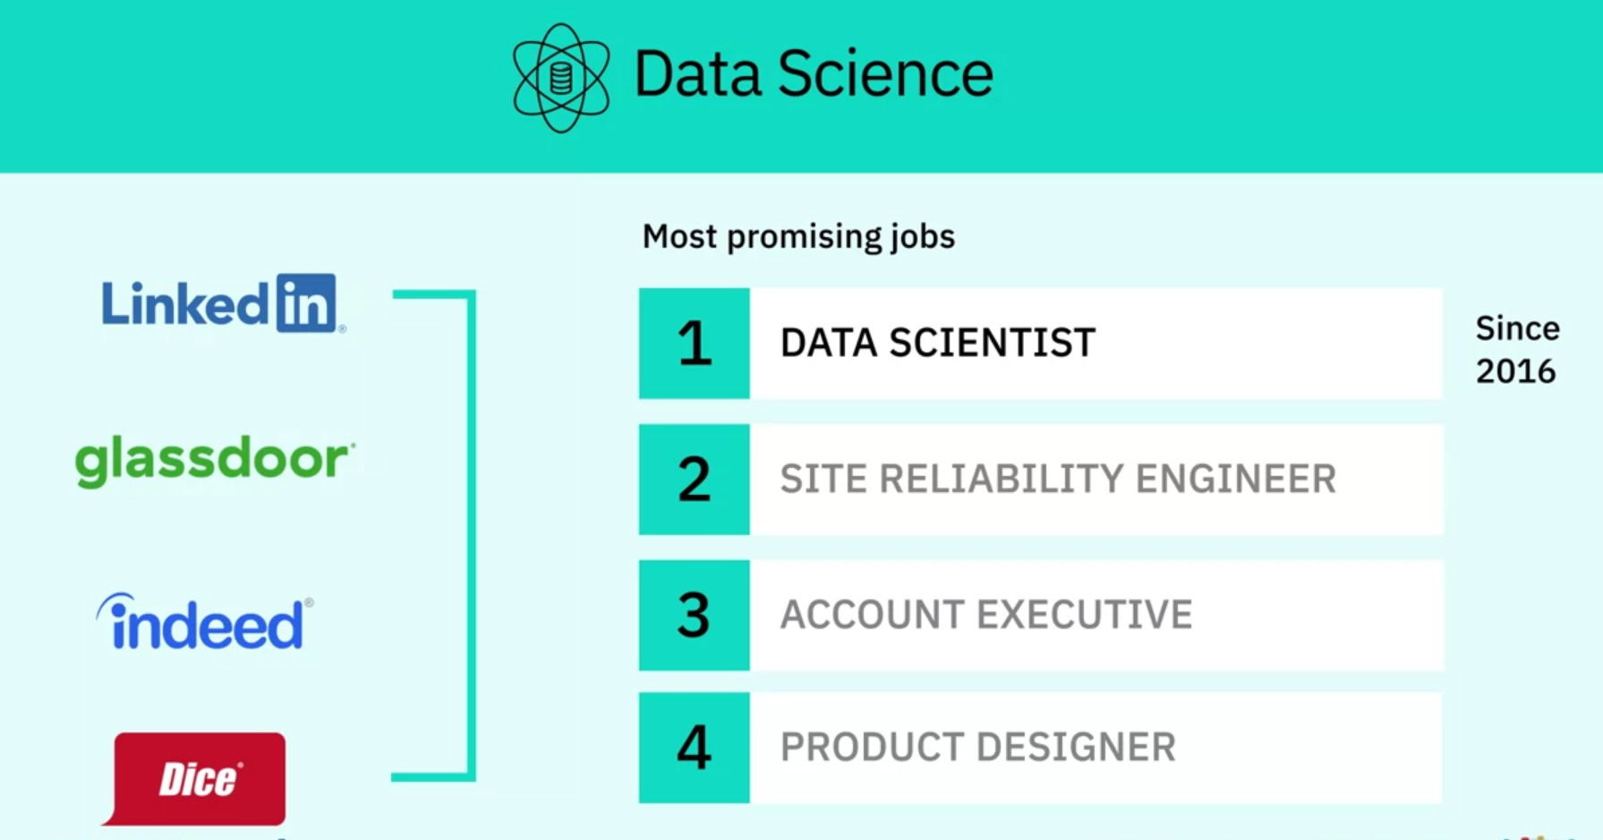

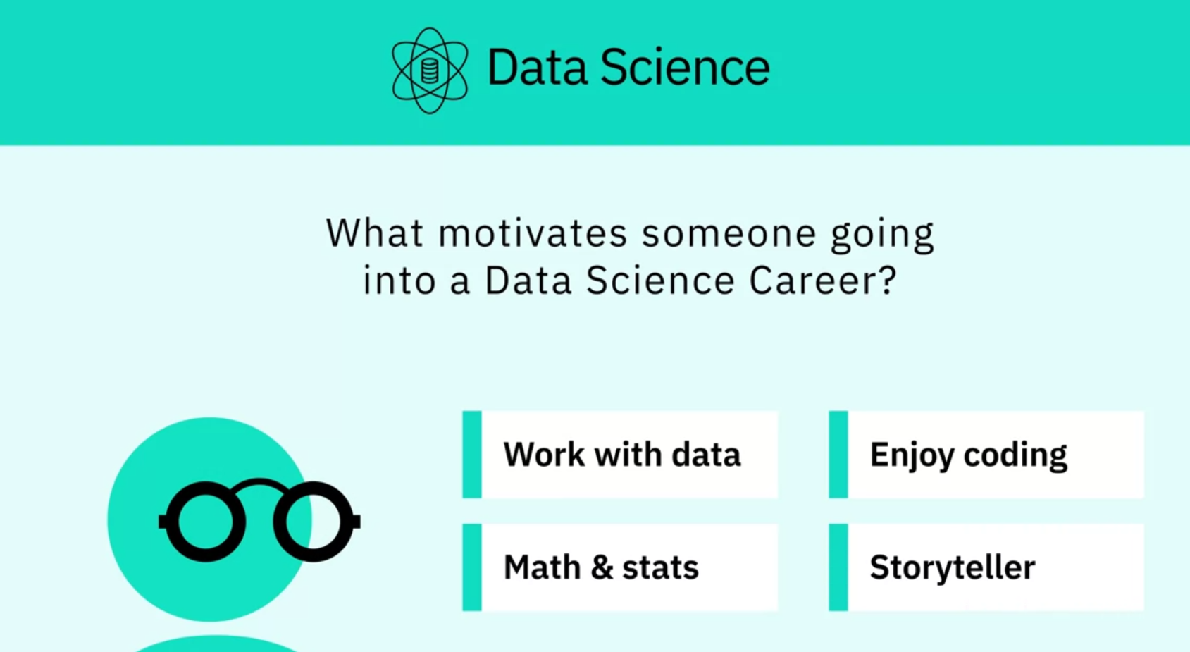

According to Dr. White, the industrial world is shifting to a new trend, and for high school students to be on the right side of this new trend, his advice to them is:

* Learn some math.
* To learn how to program.
* Learn statistics.
* Try to start experimenting with building small systems that work and are useful.
* Take a course in probability.

Summary:

* Data Scientists need programming, mathematics, and database skills, many of which can be gained through self-learning.
* Companies recruiting for a Data Science team need to understand the variety of different roles Data Scientists can play, and look for soft skills like storytelling and relationship building as well as technical skills.
* High school students considering a career in Data Science should learn programming, math, databases, and, most importantly practice their skills.

**Course Text Book: ‘Getting Started with Data Science’ Publisher: IBM Press; 1 edition (Dec 13 2015) Print.**

**Author: Murtaza Haider**



Prescribed Reading: Chapter 3 Pg. 60-62

### The Report Structure

Before starting the analysis, think about the structure of the report. Will it be a brief report of five or fewer pages, or will it be a longer document running more than 100 pages in length? The structure of the report depends on the length of the document. A brief report is more to the point and presents a summary of key findings. A detailed report incrementally builds the argument and contains details about other relevant works, research methodology, data sources, and intermediate findings along with the main results.

I have reviewed reports by leading consultants including Deloitte and McKinsey. I found that the length of the reports varied depending largely on the purpose of the report. Brief reports were drafted as commentaries on current trends and developments that attracted public or media attention. Detailed and comprehensive reports offered a critical review of the subject matter with extensive data analysis and commentary. Often, detailed reports collected new data or interviewed industry experts to answer the research questions.

Even if you expect the report to be brief, sporting five or fewer pages, I recommend that the deliverable follow a prescribed format including the cover page, table of contents, executive summary, detailed contents, acknowledgments, references, and appendices (if needed).

I often find the cover page to be missing in documents. It is not the inexperience of undergraduate students that is reflected in submissions that usually miss the cover page. In fact, doctoral candidates also require an explicit reminder to include an informative cover page. I hasten to mention that the business world sleuths are hardly any better. Just search the Internet for reports and you will find plenty of reports from reputed firms that are missing the cover page.

At a minimum, the cover page should include the title of the report, names of authors, their affiliations, and contacts, the name of the institutional publisher (if any), and the date of publication. I have seen numerous reports missing the date of publication, making it impossible to cite them without the year and month of publication. Also, from a business point of view, authors should make it easier for the reader to reach out to them. Having contact details at the front makes the task easier.

"A table of contents (ToC)" is like a map needed for a trip never taken before. You need to have a sense of the journey before embarking on it. A map provides a visual proxy for the actual travel with details about the landmarks that you will pass by in your trip. The ToC with main headings and lists of tables and figures offers a glimpse of what lies ahead in the document. Never shy away from including a ToC, especially if your document, excluding cover page, table of contents, and references, is five or more pages in length.

Even for a short document, I recommend an "abstract" or an "executive summary". Nothing is more powerful than explaining the crux of your arguments in three paragraphs or less. Of course, for larger documents running a few hundred pages, the executive summary could be longer. An "introductory section" is always helpful in setting up the problem for the reader who might be new to the topic and who might need to be gently introduced to the subject matter before being immersed in intricate details. A good follow-up to the introductory section is a review of available relevant research on the subject matter. The length of the literature review section depends upon how contested the subject matter is. In instances where the vast majority of researchers have concluded in one direction, the literature review could be brief with citations for only the most influential authors on the subject. On the other hand, if the arguments are more nuanced with caveats aplenty, then you must cite the relevant research to offer adequate context before you embark on your analysis. You might use the literature review to highlight gaps in the existing knowledge, which your analysis will try to fill. This is where you formally introduce your research questions and hypothesis.

In the "methodology" section, you introduce the research methods and data sources you used for the analysis. If you have collected new data, explain the data collection exercise in some detail. You will refer to the literature review to bolster your choice for variables, data, and methods and how they will help you answer your research questions.

The results section is where you present your empirical findings. Starting with descriptive statistics (**see Chapter 4, "Serving Tables"**) and illustrative graphics (**see Chapter S, "Graphic Details" for plots and Chapter 10, "Spatial Data Analytics" for maps**), you will move toward formally testing your hypothesis (**see Chapter 6, "Hypothetically Speaking"**).

In case you need to run statistical models, you might turn to regression models (**see Chapter 7, "Why Tall Parents Don't Have Even Taller Children"**) or categorical analysis (**see Chapters 8, "To Be or Not to Be" and 2., "Categorically Speaking About Categorical Data"**). If you are working with time-series data, you can turn to Chapter 11, **Doing Serious Time with Time Series.** You can also report results from other empirical techniques that fall under the general rubric of data mining (**see Chapter 12, "Data Mining for Gold"**). Note that many reports in the business sector present results in a more palatable fashion by holding back the statistical details and relying on illustrative graphics to summarize the results.

The results section is followed by the discussion section, where you craft your main arguments by building on the results you have presented earlier.

The "discussion section" is where you rely on the power of narrative to enable numbers to communicate your thesis to your readers. You refer the reader to the research question and the knowledge gaps you identified earlier. You highlight how your findings provide the ultimate missing piece to the puzzle.

Of course, not all analytics return a smoking gun. At times, more frequently than I would like to acknowledge, the results provide only a partial answer to the question and that, too, with a long list of caveats.

In the "conclusion" section, you generalize your specific findings and take on a rather marketing approach to promote your findings so that the reader does not remain stuck in the caveats that you have voluntarily outlined earlier. You might also identify future possible developments in research and applications that could result from your research. What remains is housekeeping, including a list of references, the acknowledgment section (**acknowledging the support of those who have enabled your work is always good**), and "appendices", if needed.

## Have You Done Your Job as a Writer?

As a data scientist, you are expected to do thorough analysis with the appropriate data, deploying the appropriate tools. As a writer, you are responsible for communicating your findings to the readers. Transport Policy, a leading research publication in transportation planning, offers a checklist for authors interested in publishing with the journal. The checklist is a series of questions authors are expected to consider before submitting their manuscripts to the journal. I believe the checklist is useful for budding data scientists and, therefore, I have reproduced it verbatim for their benefit.

* Have you told readers, at the outset, what they might gain by reading your paper?
* Have you made the aim of your work clear?
* Have you explained the significance of your contribution?
* Have you set your work in the appropriate context by giving sufficient background (including a complete set of relevant references) to your work?
* Have you addressed the question of practicality and usefulness?
* Have you identified future developments that might result from your work?
* Have you structured your paper in a clear and logical fashion?

**Summary:**

* The length and content of the final report will vary depending on the needs of the project.
* The structure of the final report for a Data Science project should include a cover page, table of contents, executive summary, detailed contents, acknowledgements, references and appendices.
* The report should present a thorough analysis of the data and communicate the project findings.